Server hardening, db. hardening, os hardening

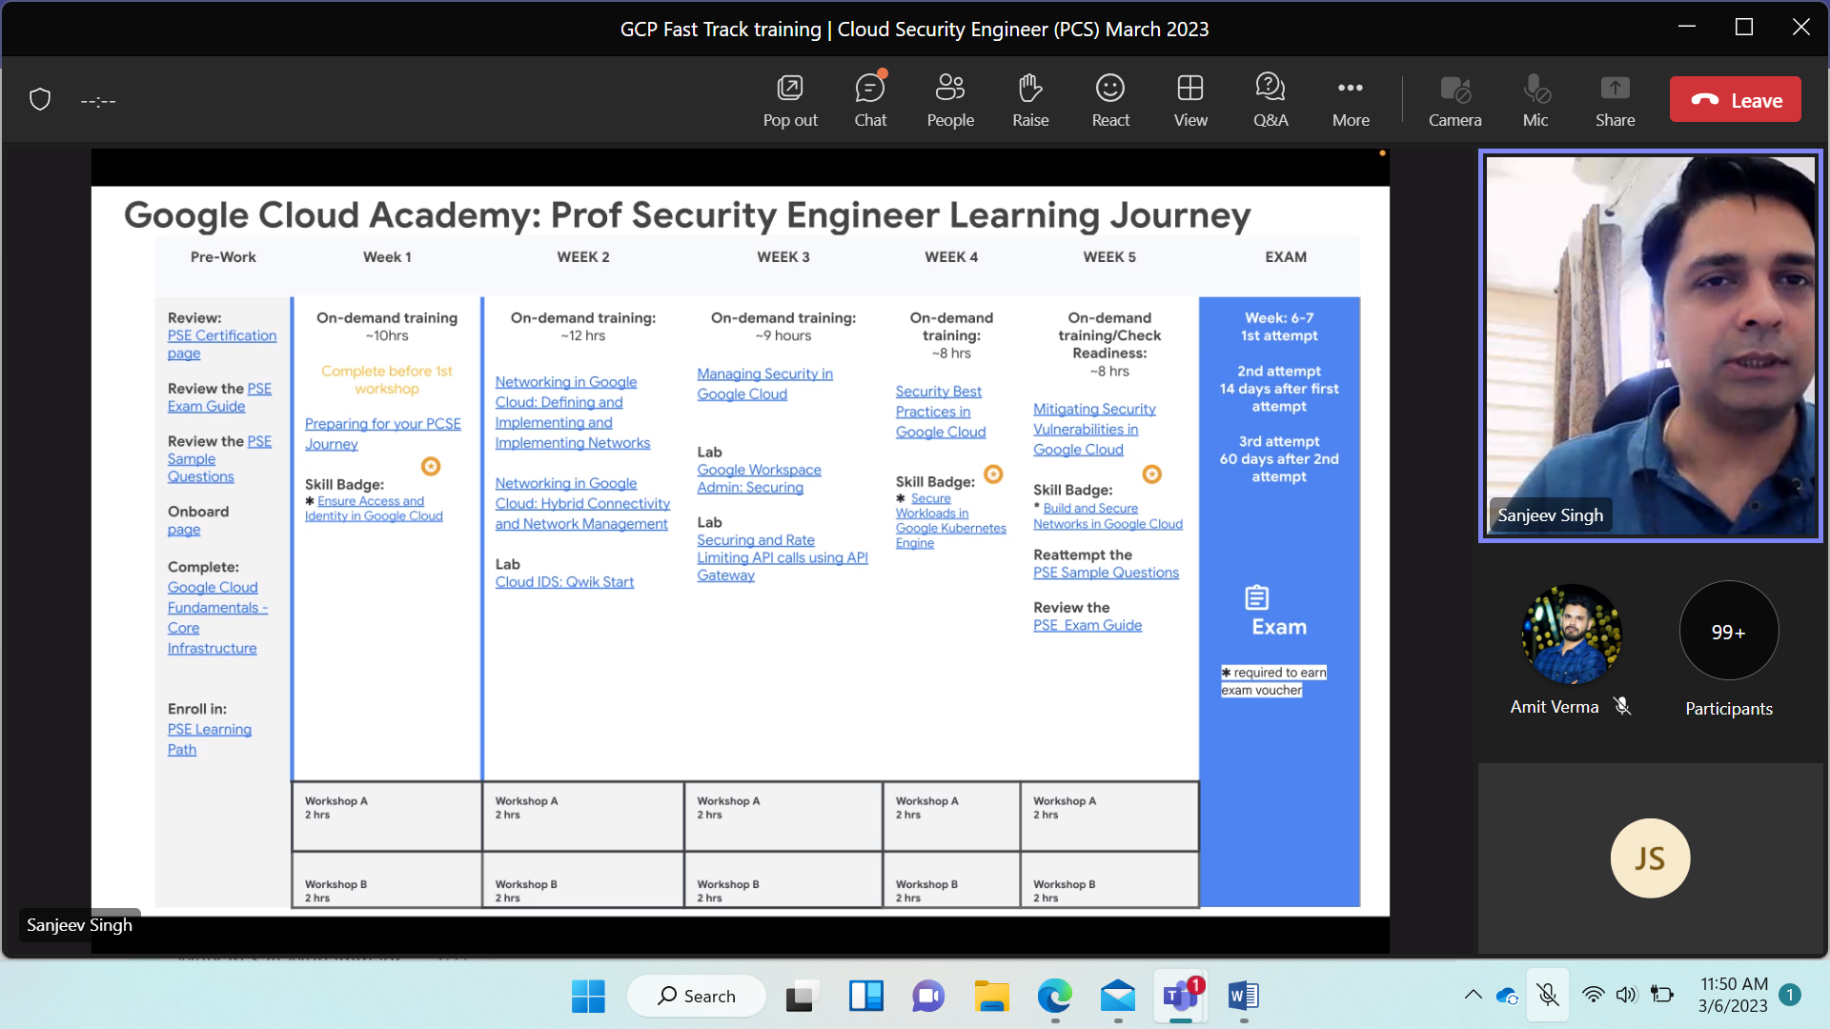

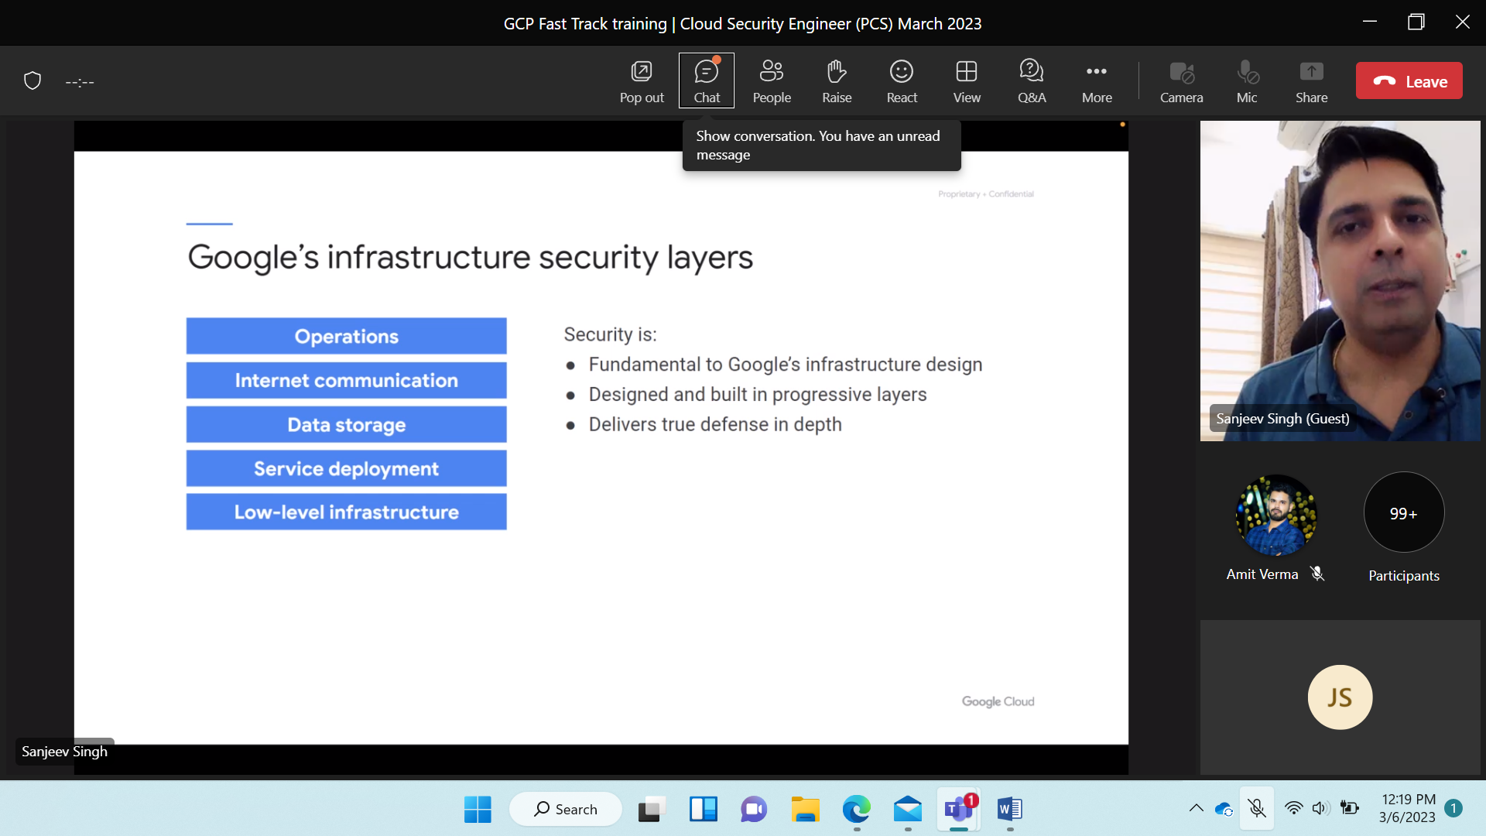

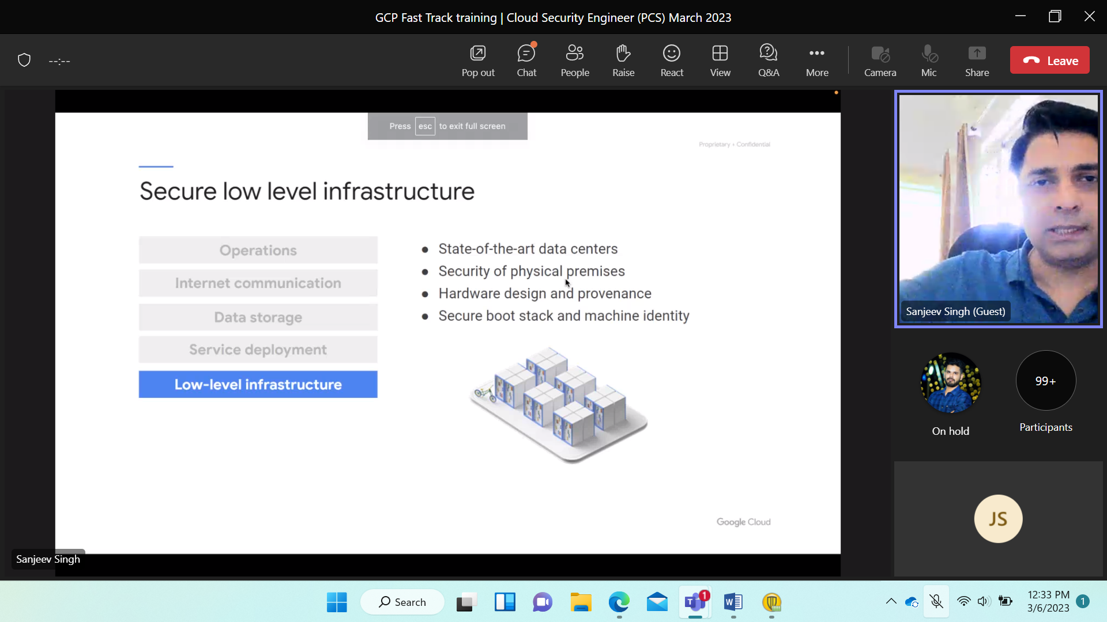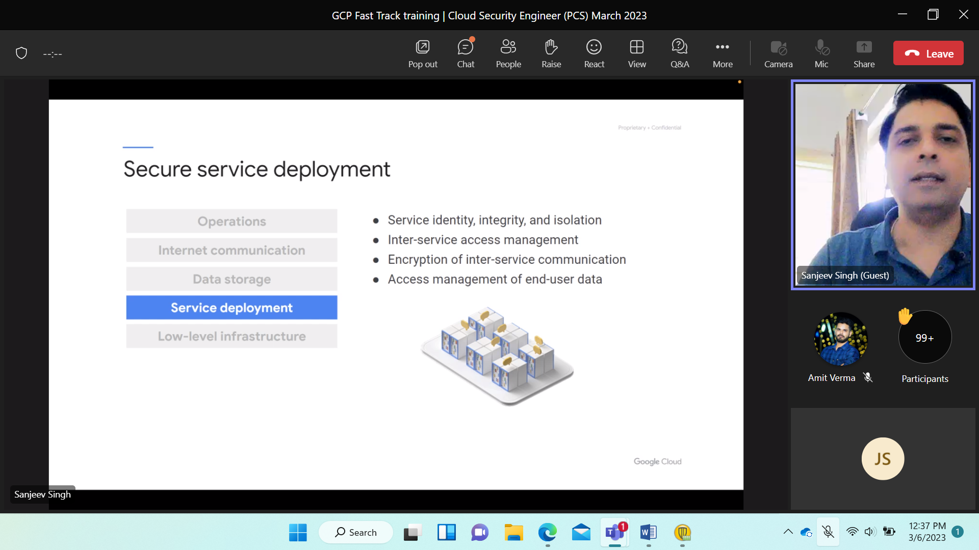

1 component attacked doesn’t mean everything is hijacked. isolation property.

Hypervisor. kernel comm is again encrypted. Key rotation, key management.

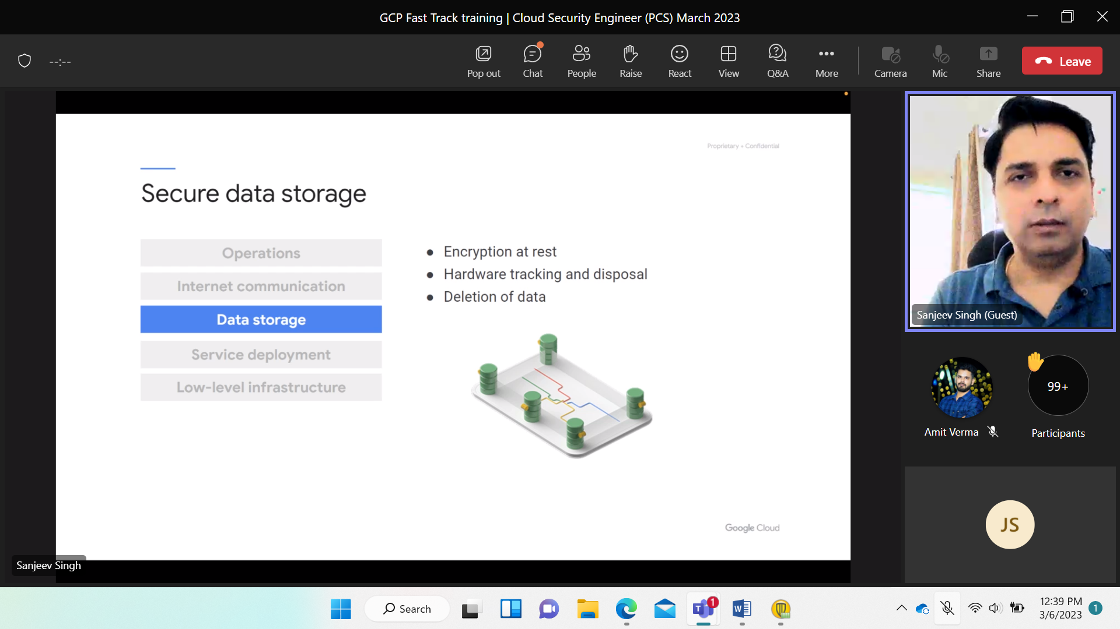

Storing data- data in transit use tls.. Use h/w security model HSM. Use G transfer from premises to cloud.

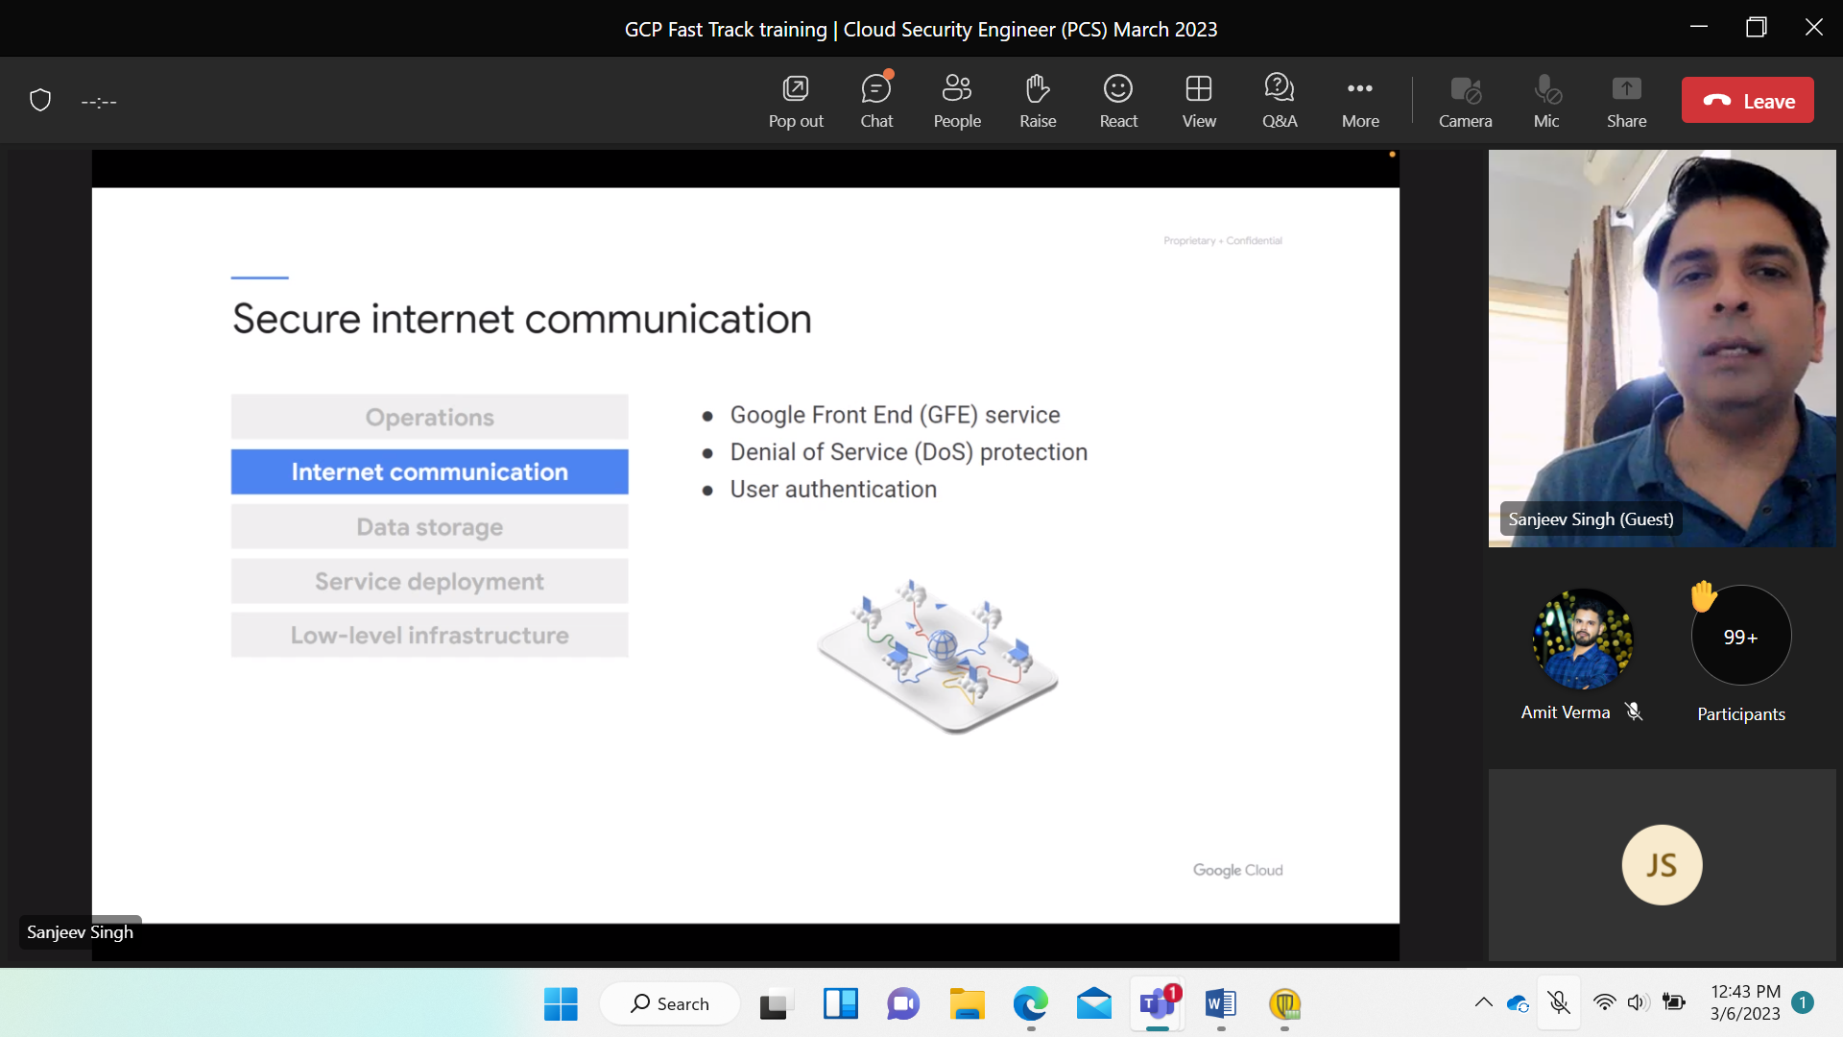

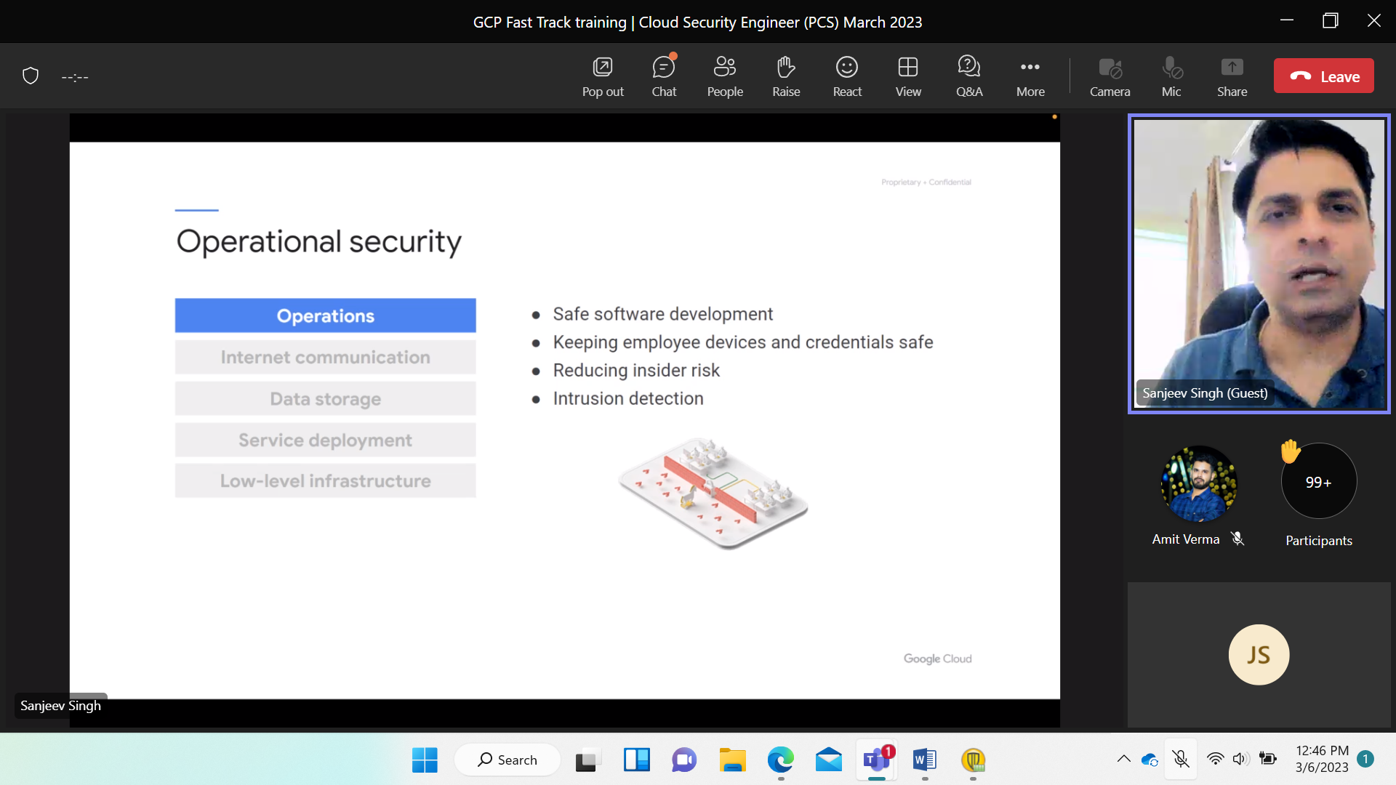

VPC n/w security Virtual private

Engg. vpc logically isolated. isolation w/ cloud acc.

Divide create subnets… control public int. ingress and egress traffic via firewall.

Flow traffic within vpc.

Operating Monitoring.

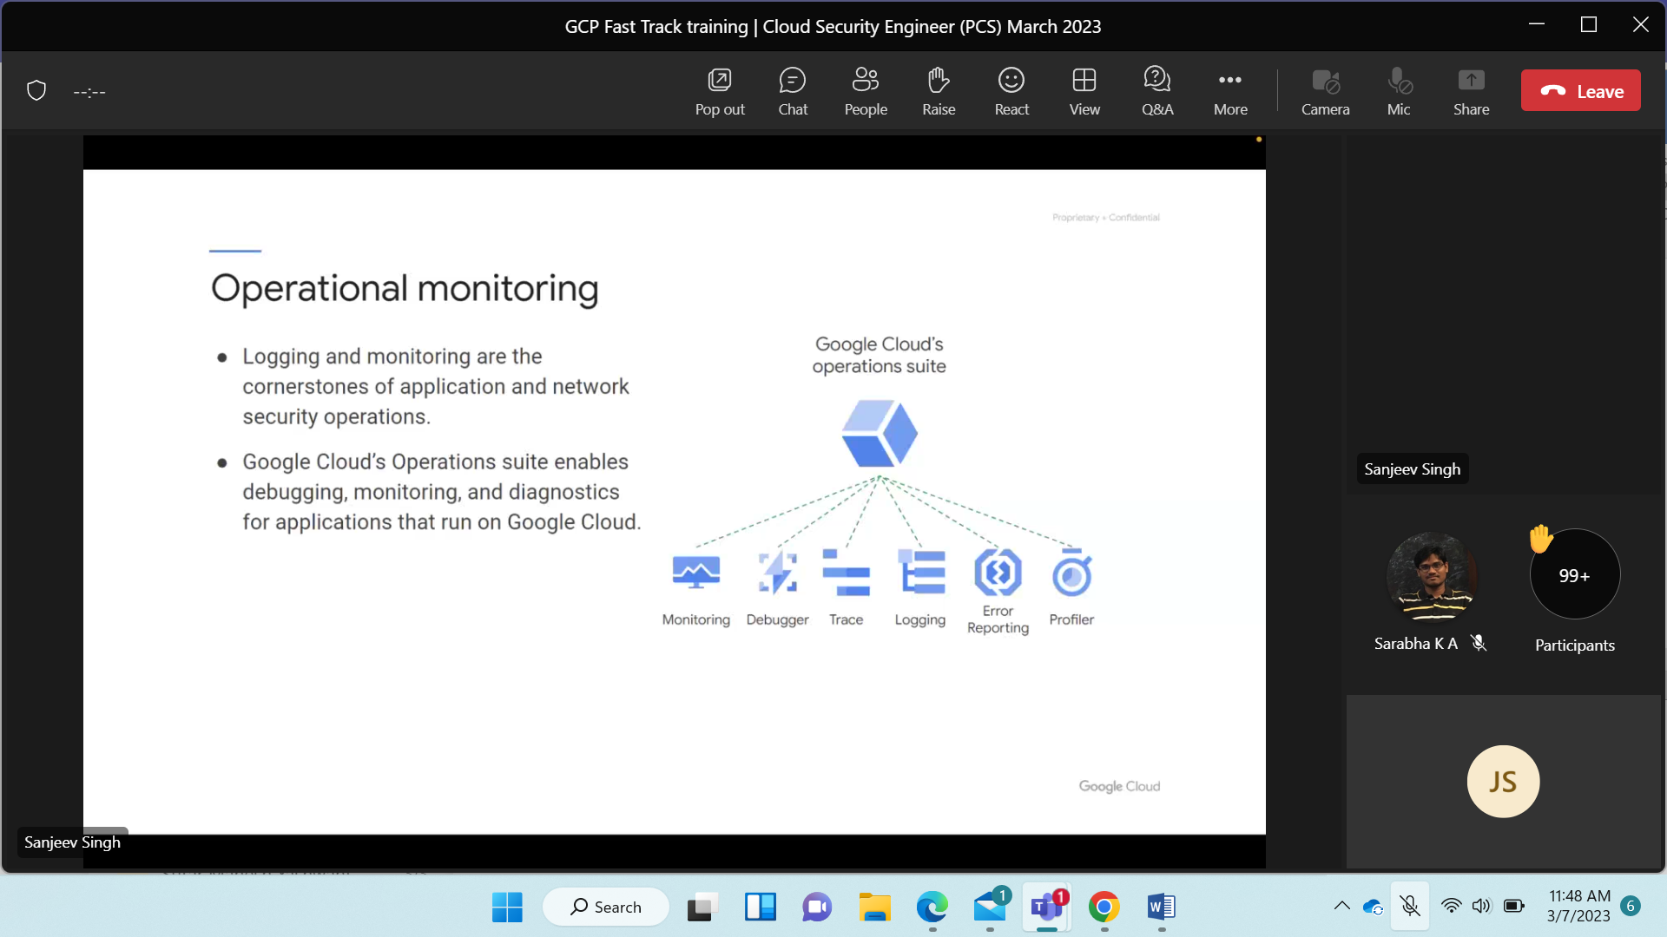

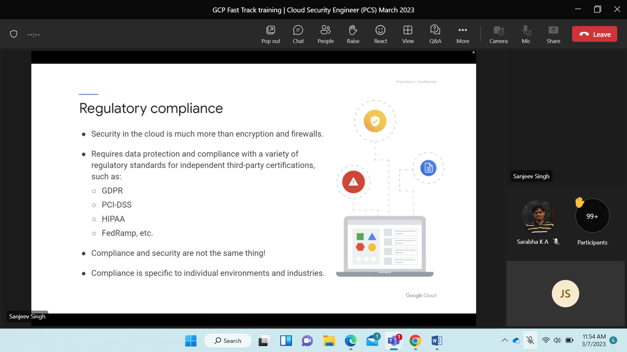

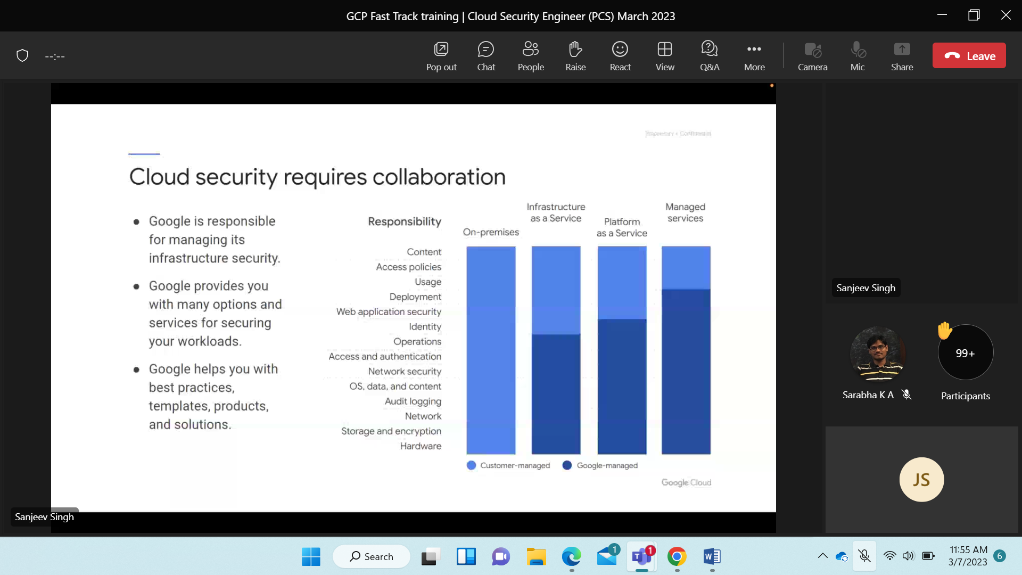

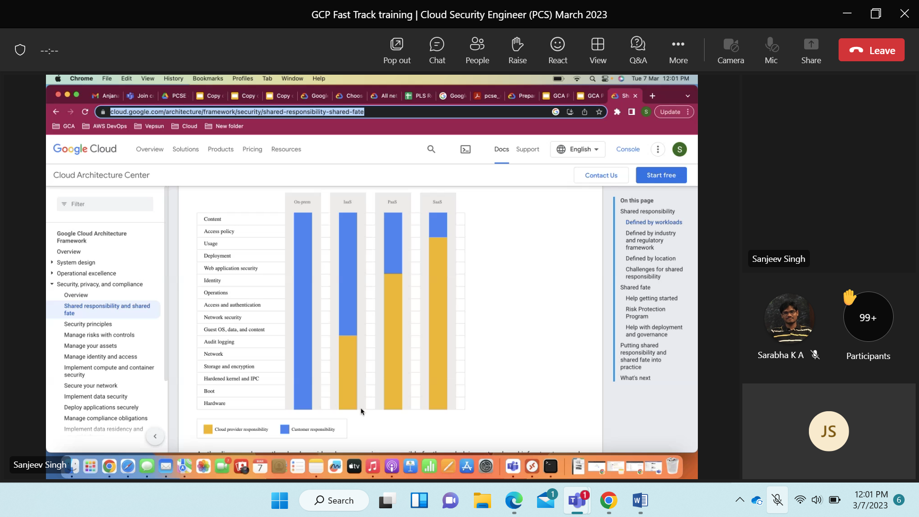

Pass is deployed further vendor like google can work on it.

SAAS is not deployed…

In security IAAS AND PAAS is important.

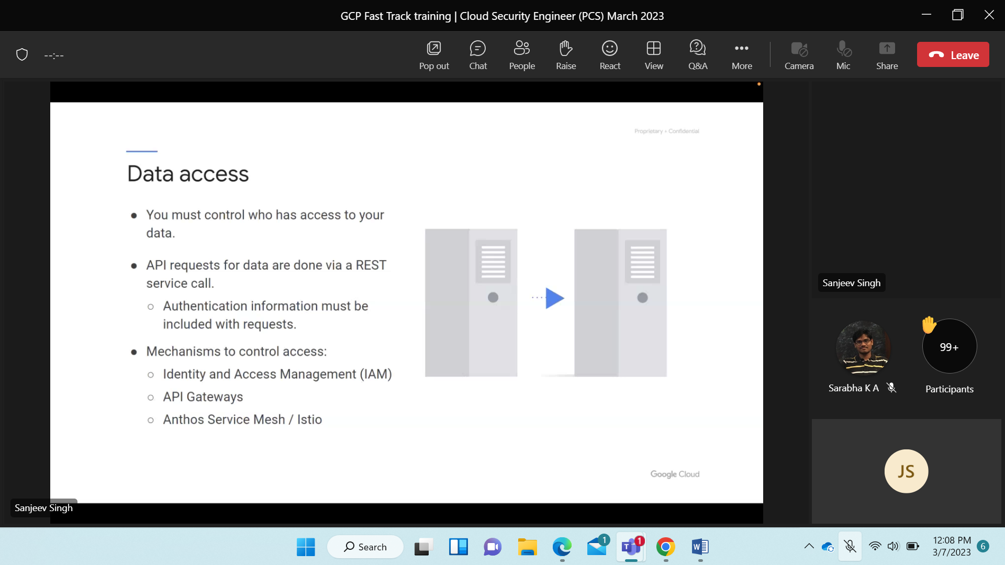

Process of zero trust should be keep in mind.

Unknown req. from unknown device should not be allowed.

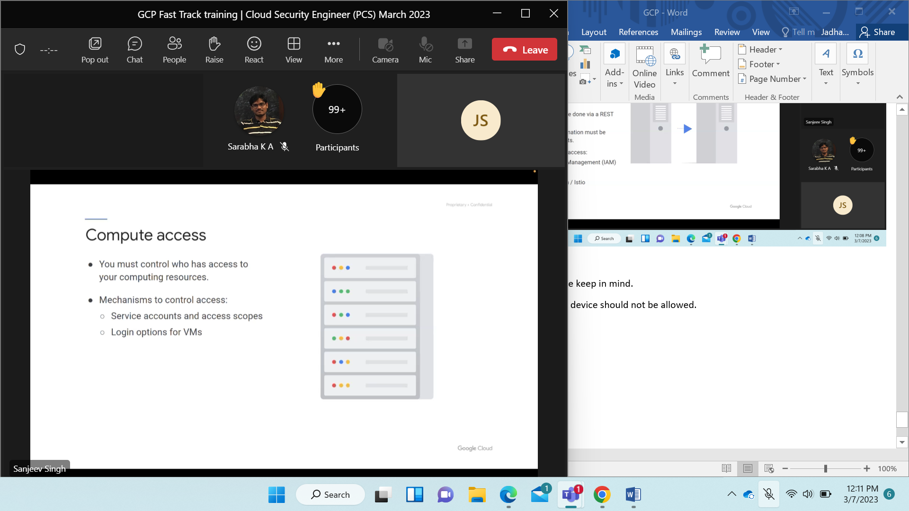

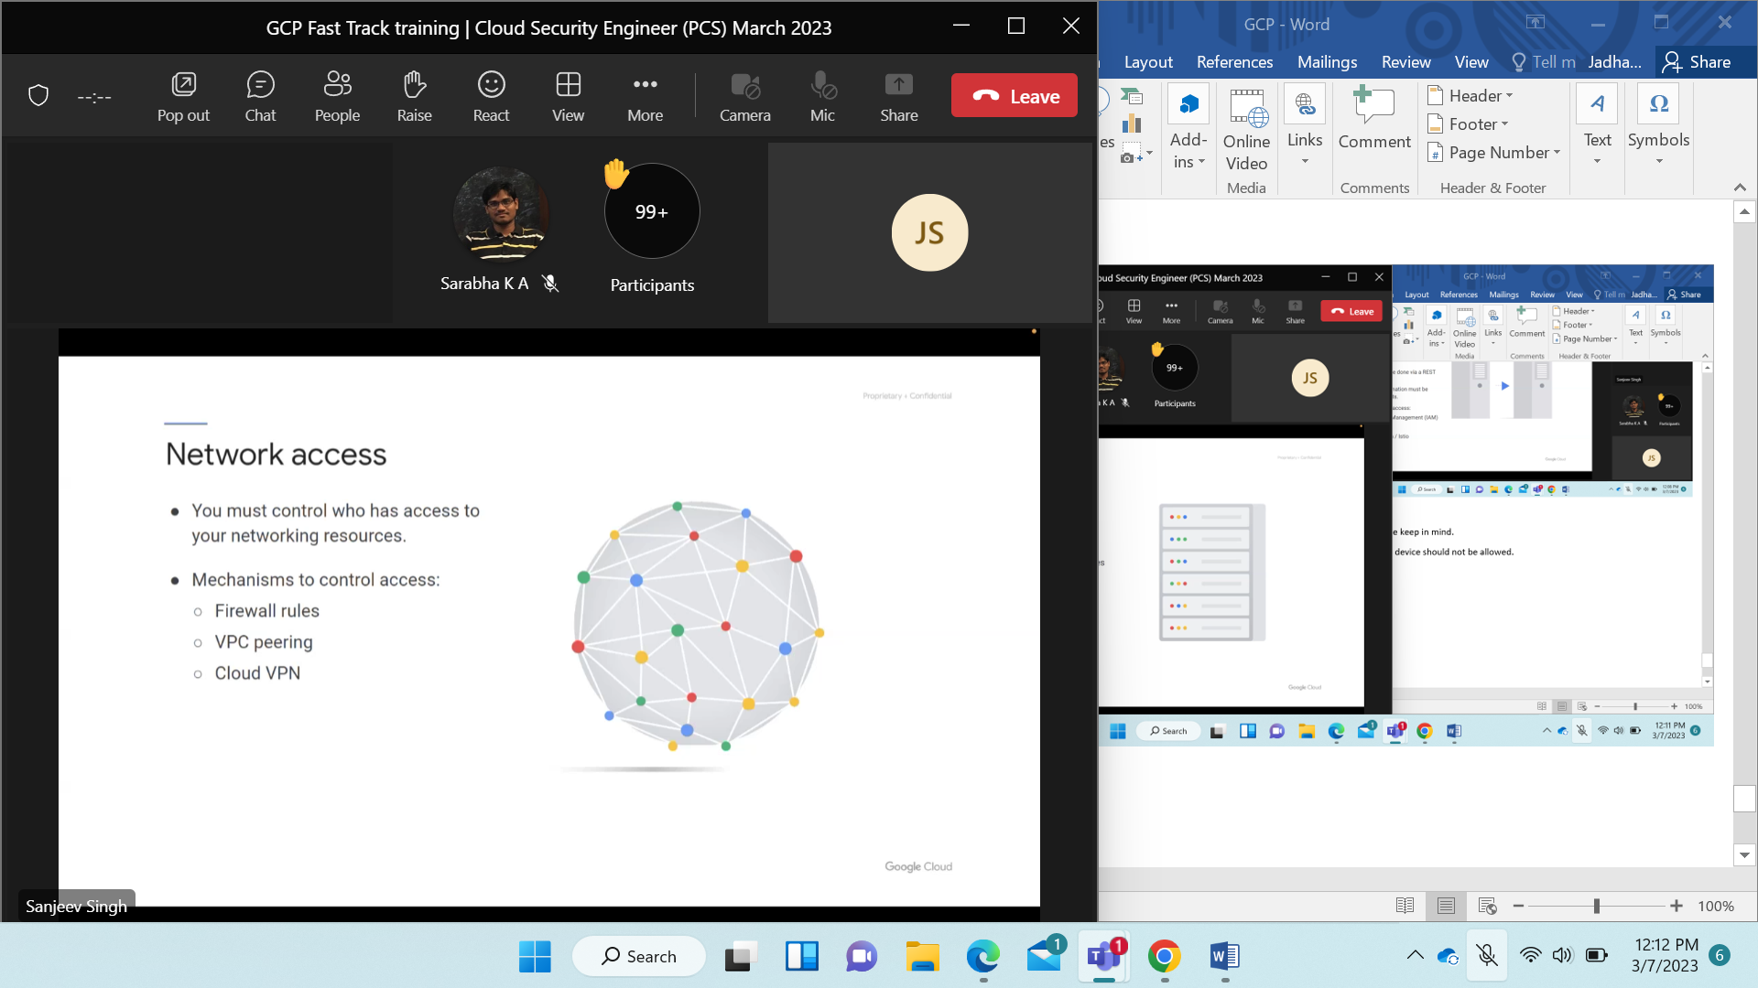

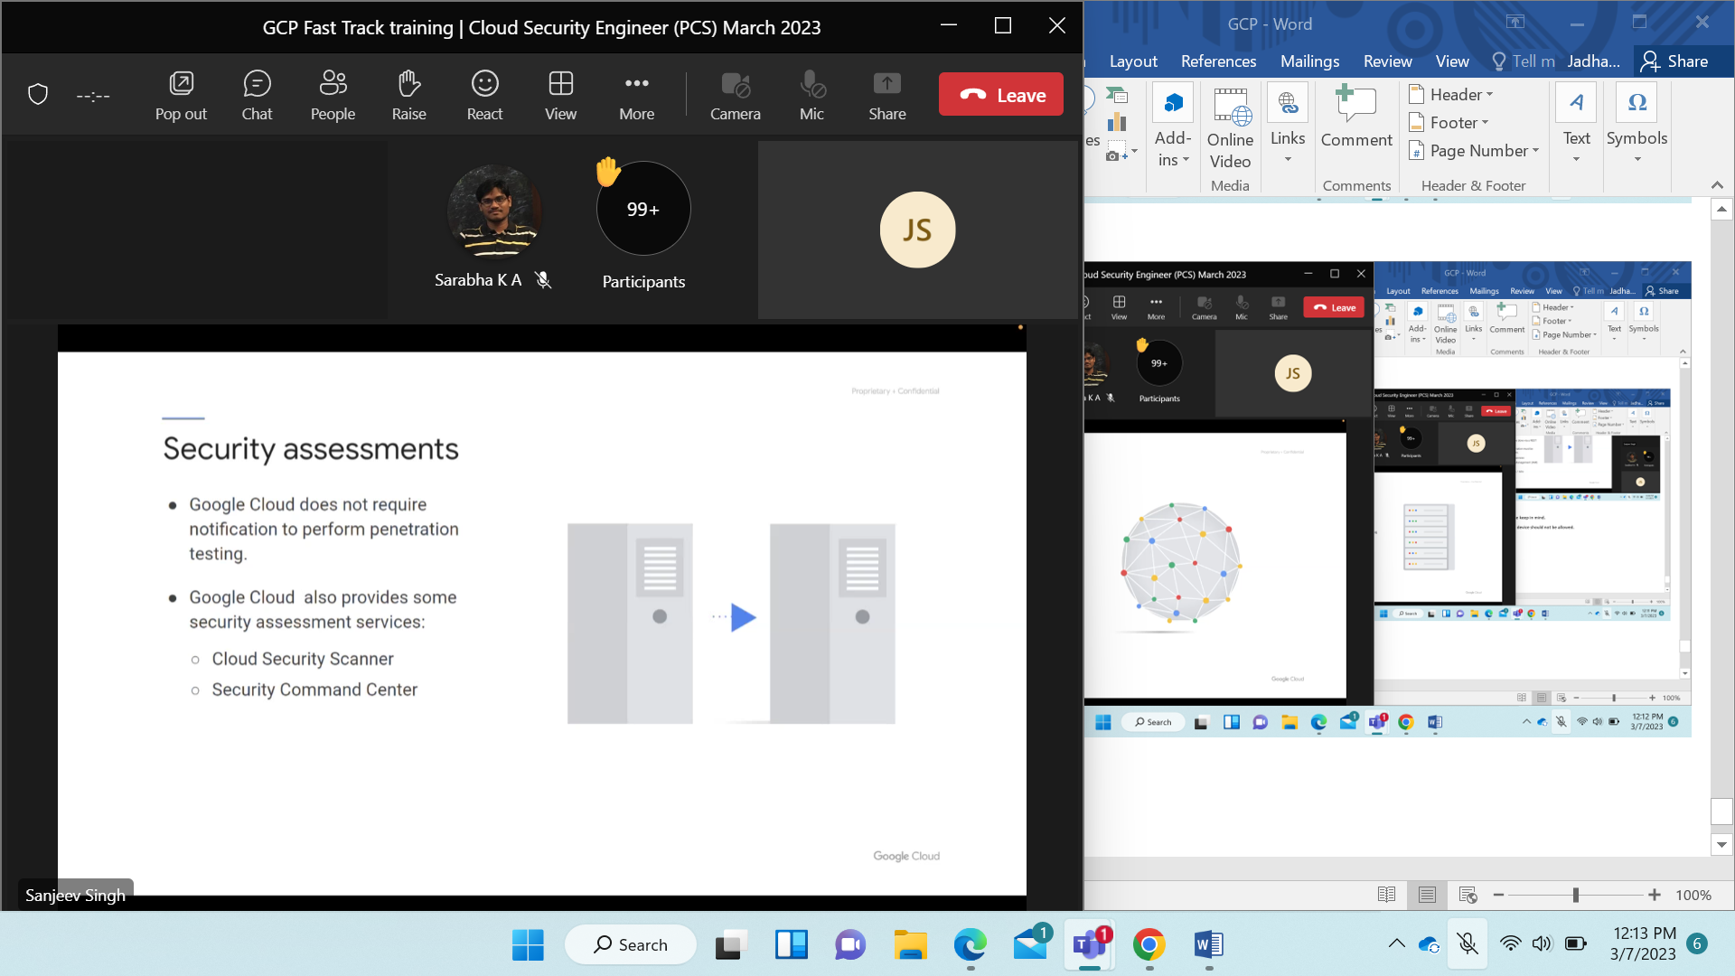

2 suit/options using for security assessment.

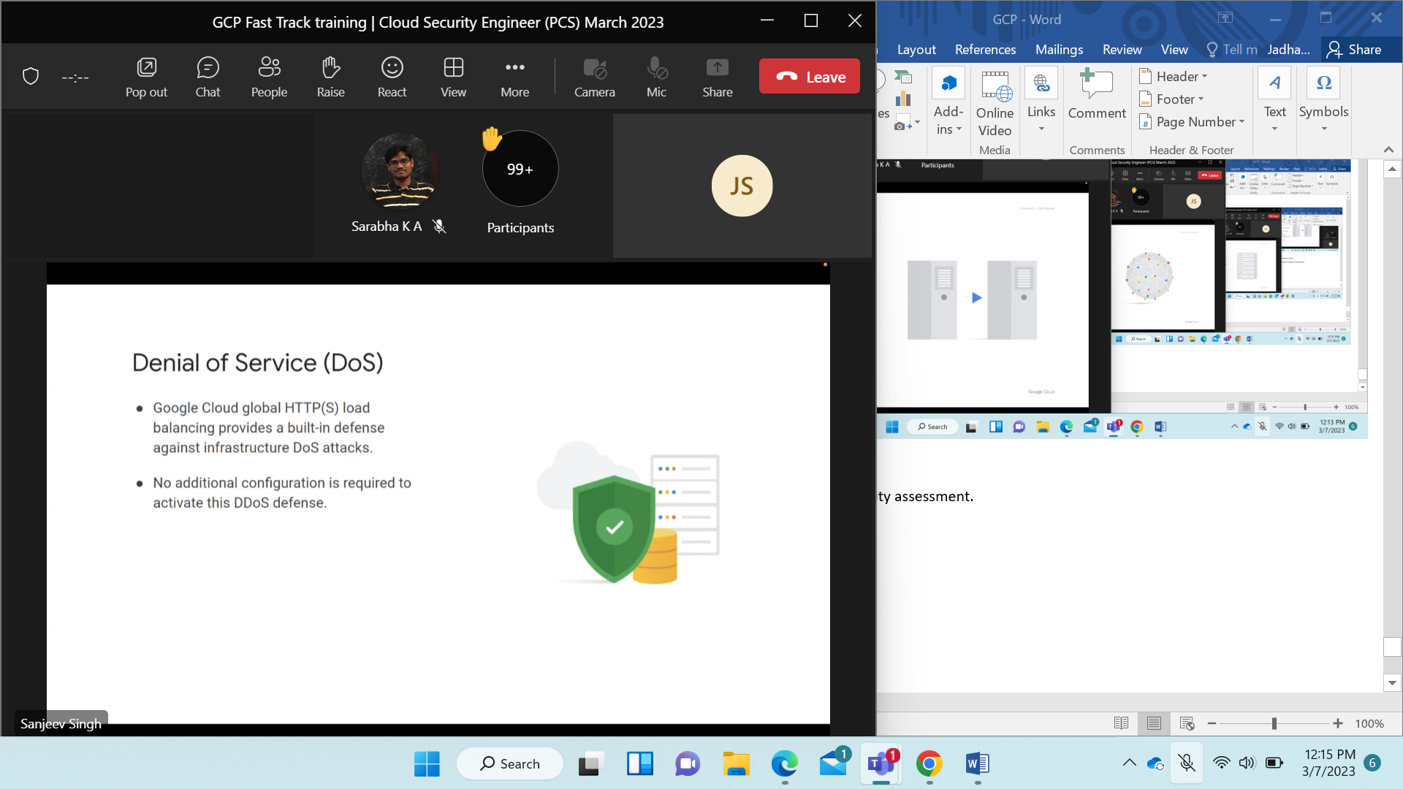

Auto scalar by load balancing

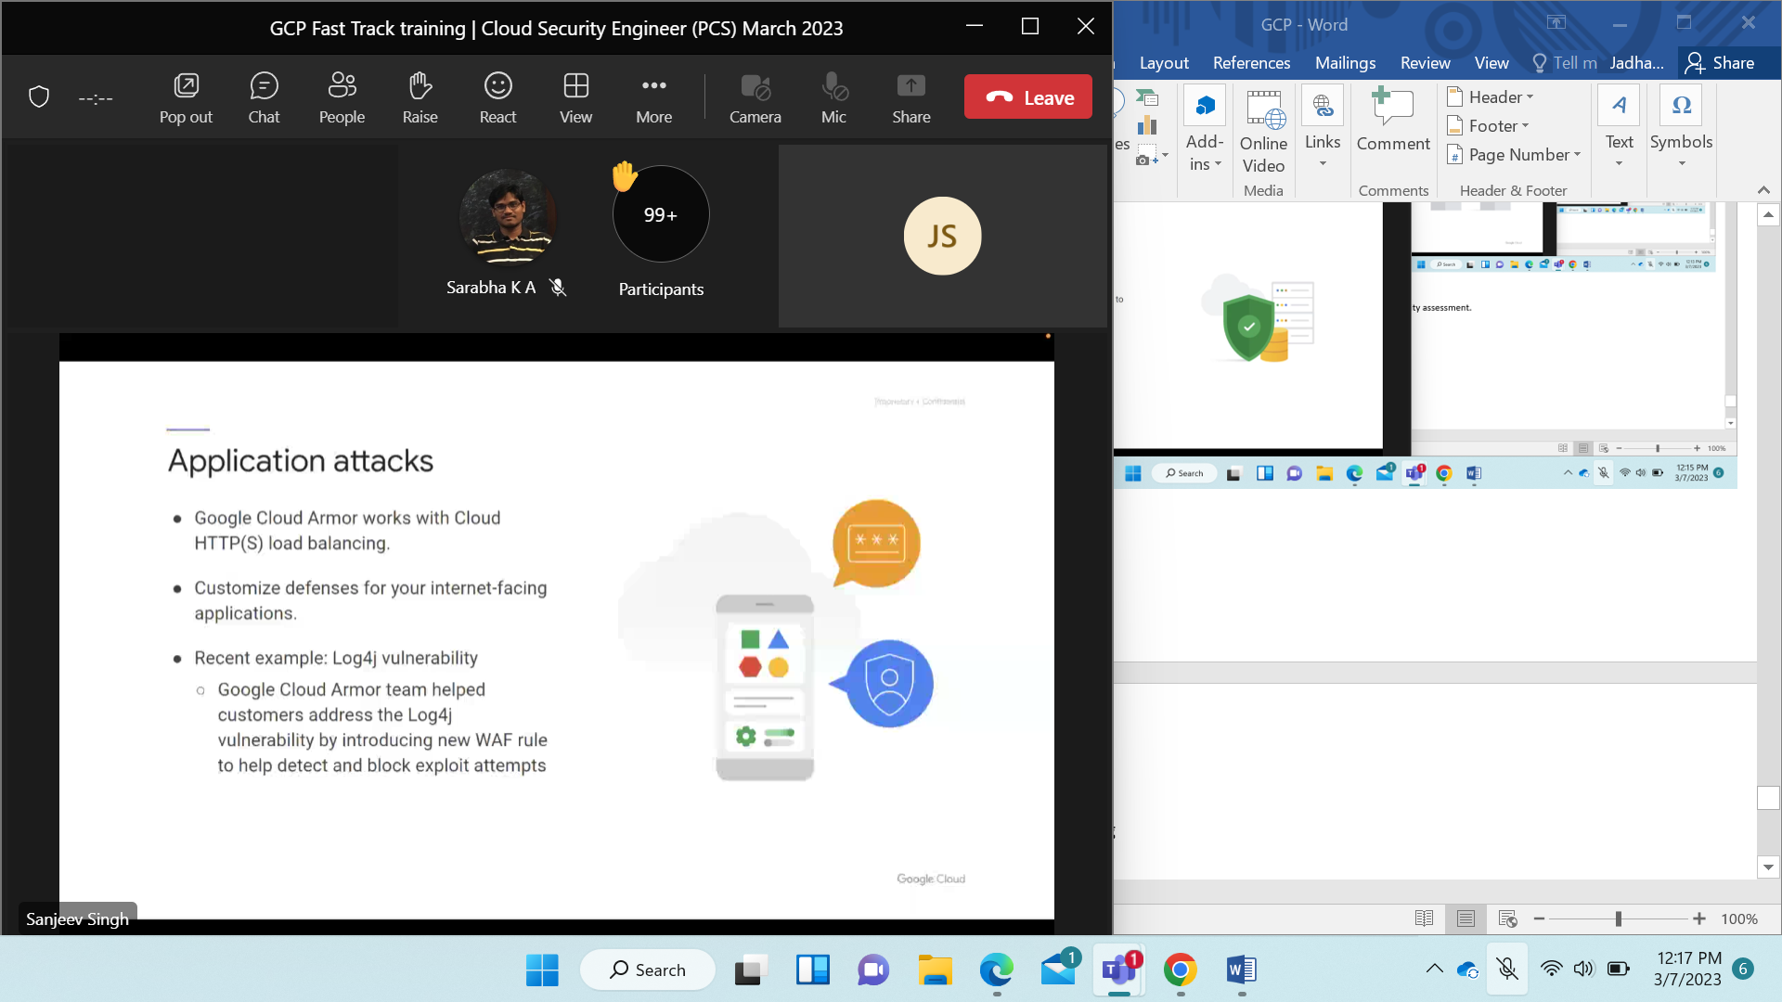

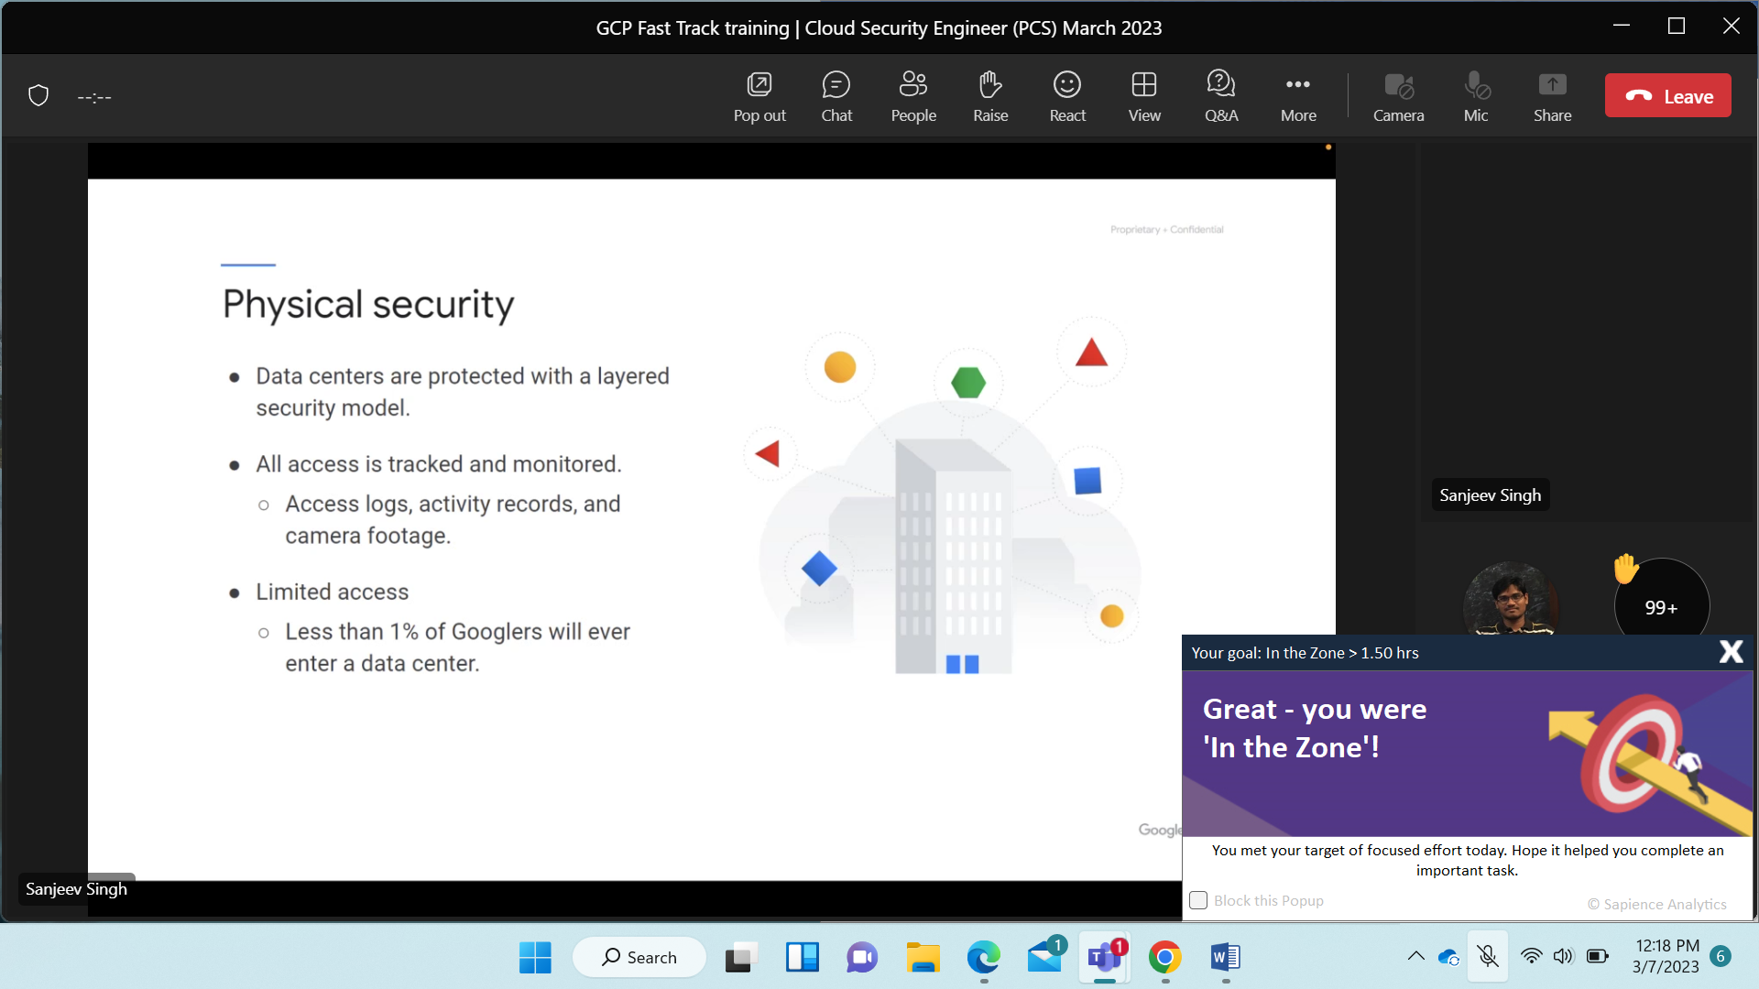

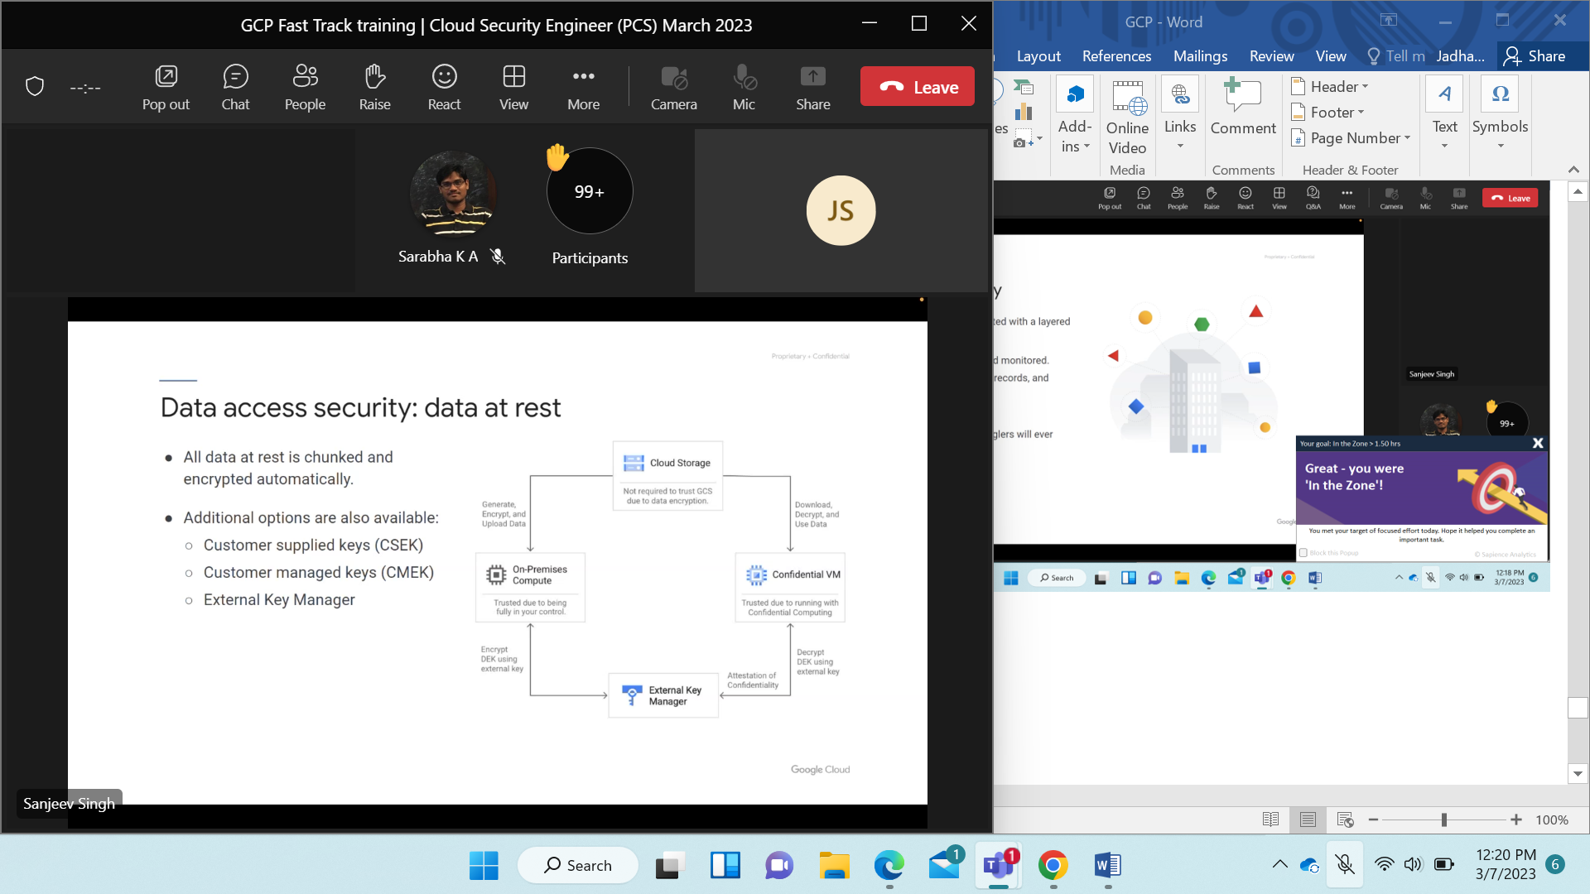

G had default data security. and has 6 more options.

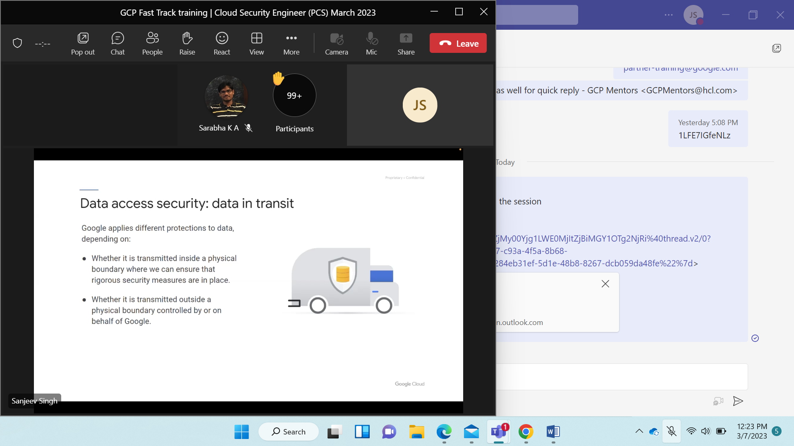

Outside G control use TLS protocol.

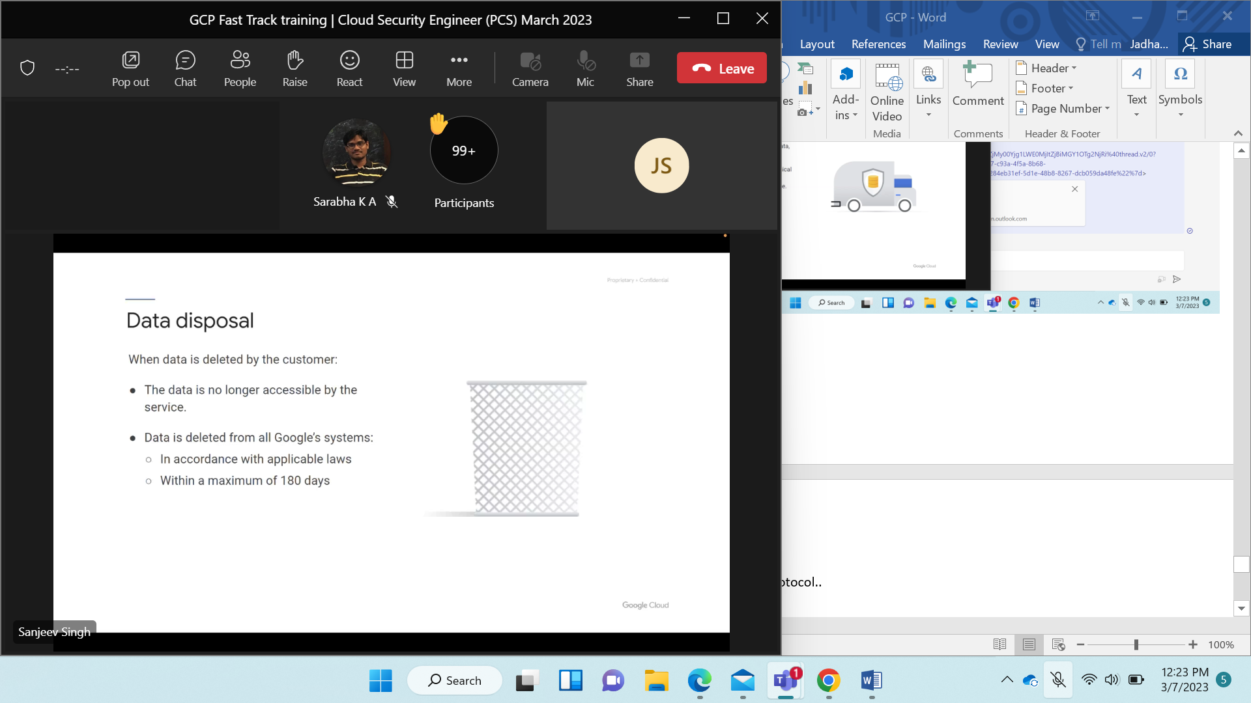

Decommission the server. ITIL best practices are followed.

Archival is done first. day at decommission approval of user is taken.

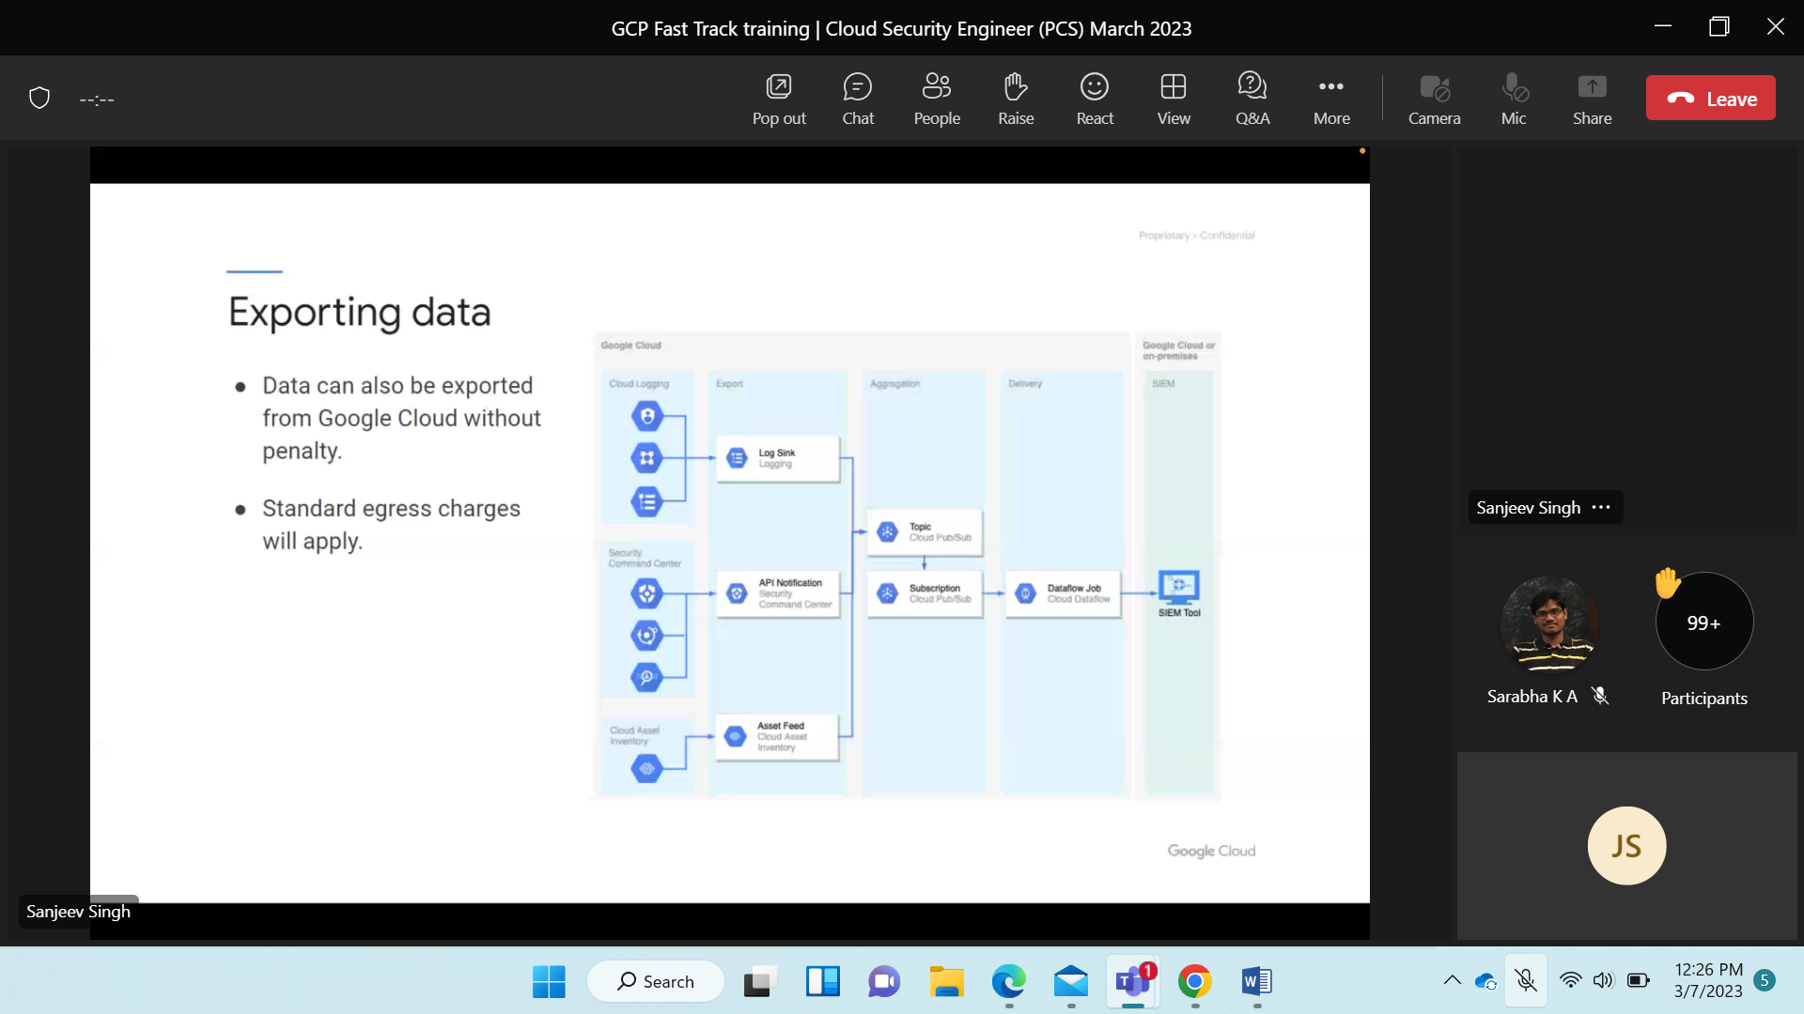Transferring data from one loc to another i.e. region. charges are applied by van.

Same zone in one region i.e. lan the charges are not applied.

No vendor locking is done by Google. egress charges are charged that is how much data is being transferred.

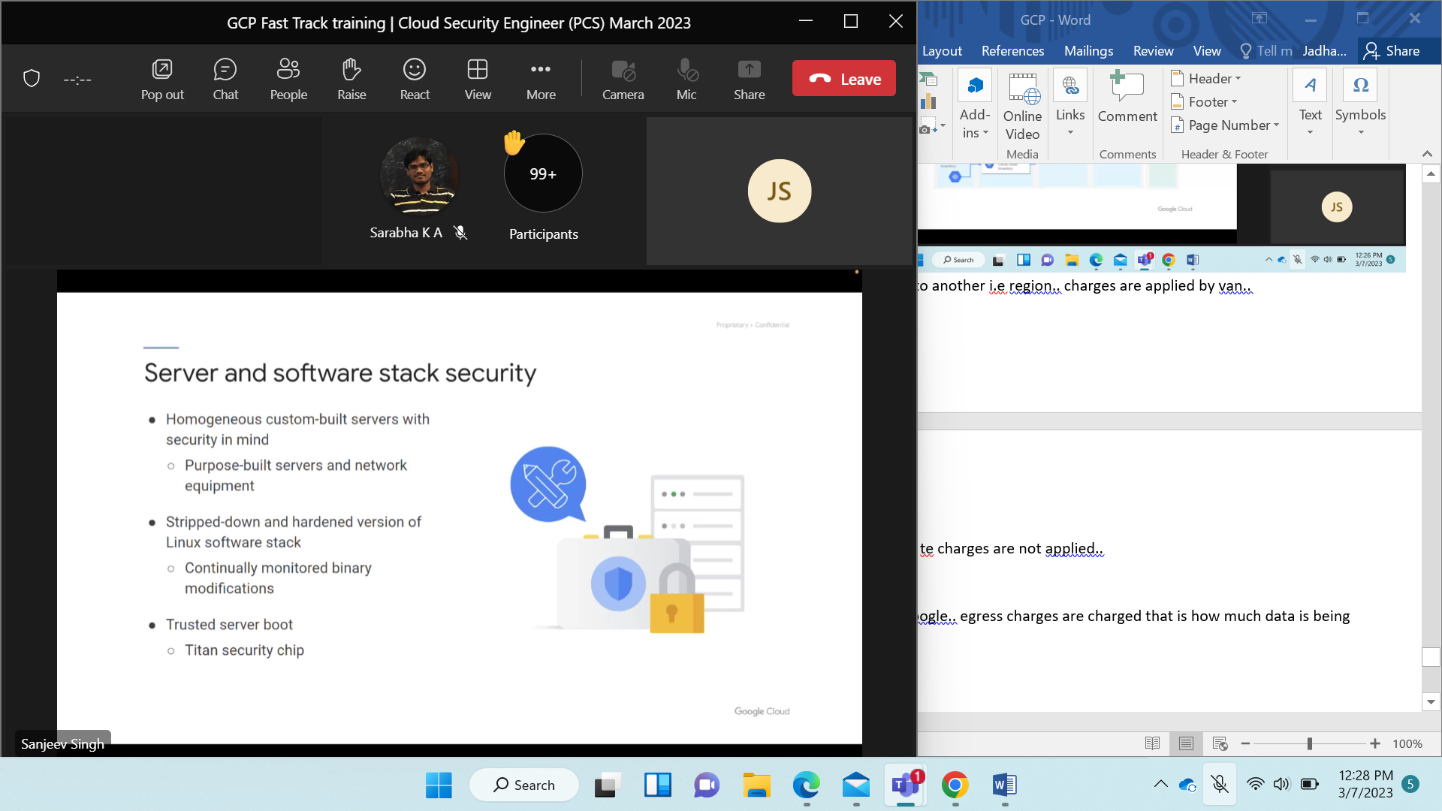

Custom built and optimized i.e. power consumption.

Harden the server, db., n/w, os. means securing it from external environment.

Go to os hardening GFG site.

GCP hardening—kubernate link 1st link.

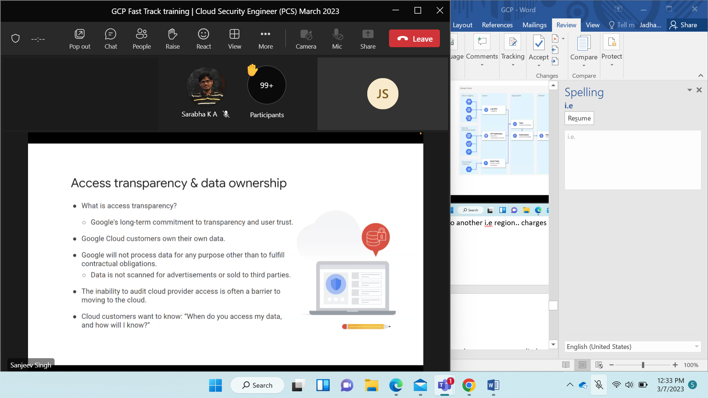

GC is separate.. no access to data for advt.

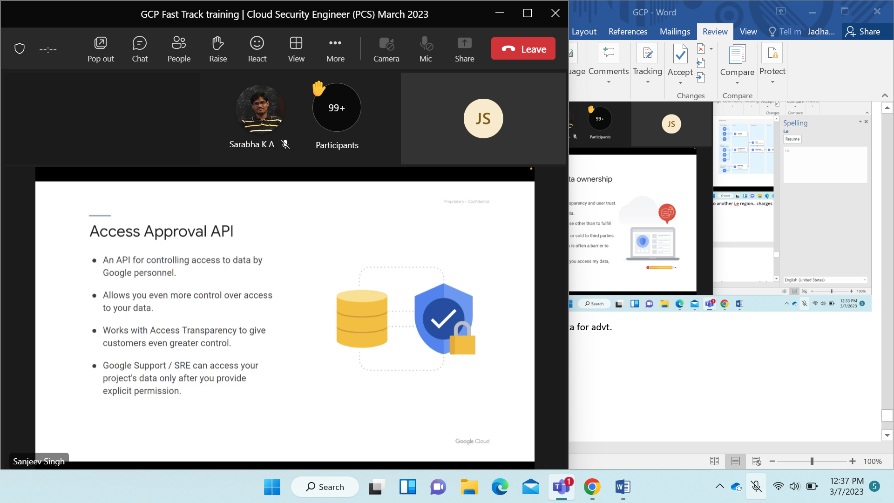

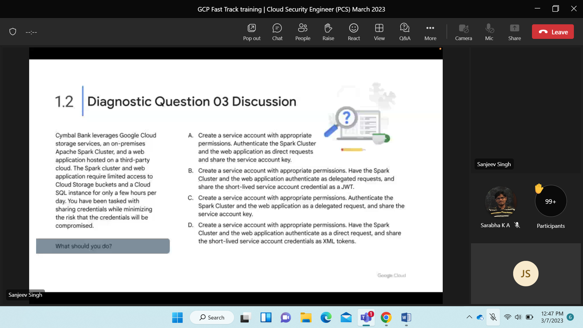

A Key is shared then unnecessary exposure happens.. Wrong.

C key for long duration unnecessary exposure for longer duration.. wrong

D it is secure but delegated req instead of direct is better.. wrong

B right..

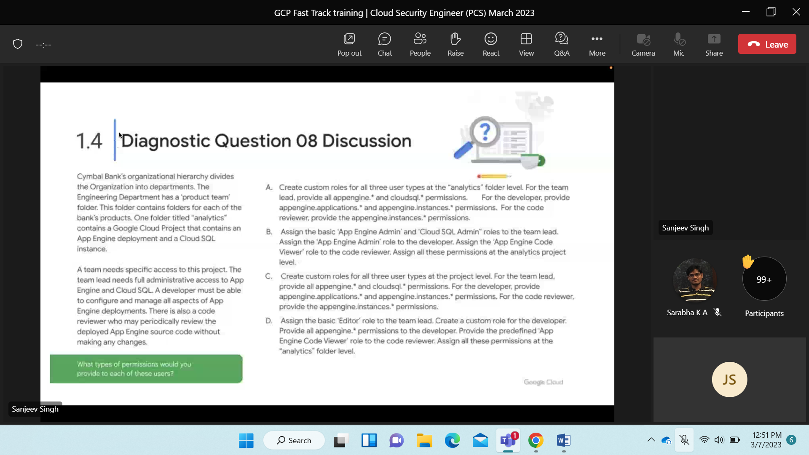

D wrong.. no logic of creating customer.. G DAS APP DEV GIVE IT TO DEVELOPER..

NOT ASSIGN EDITOR ROLE

C wrong.. predefined role is not there then create custom role.. no reqn for it.. full access app engine admin role..

B right.. team lead got full access..

A wrong.. custom role..

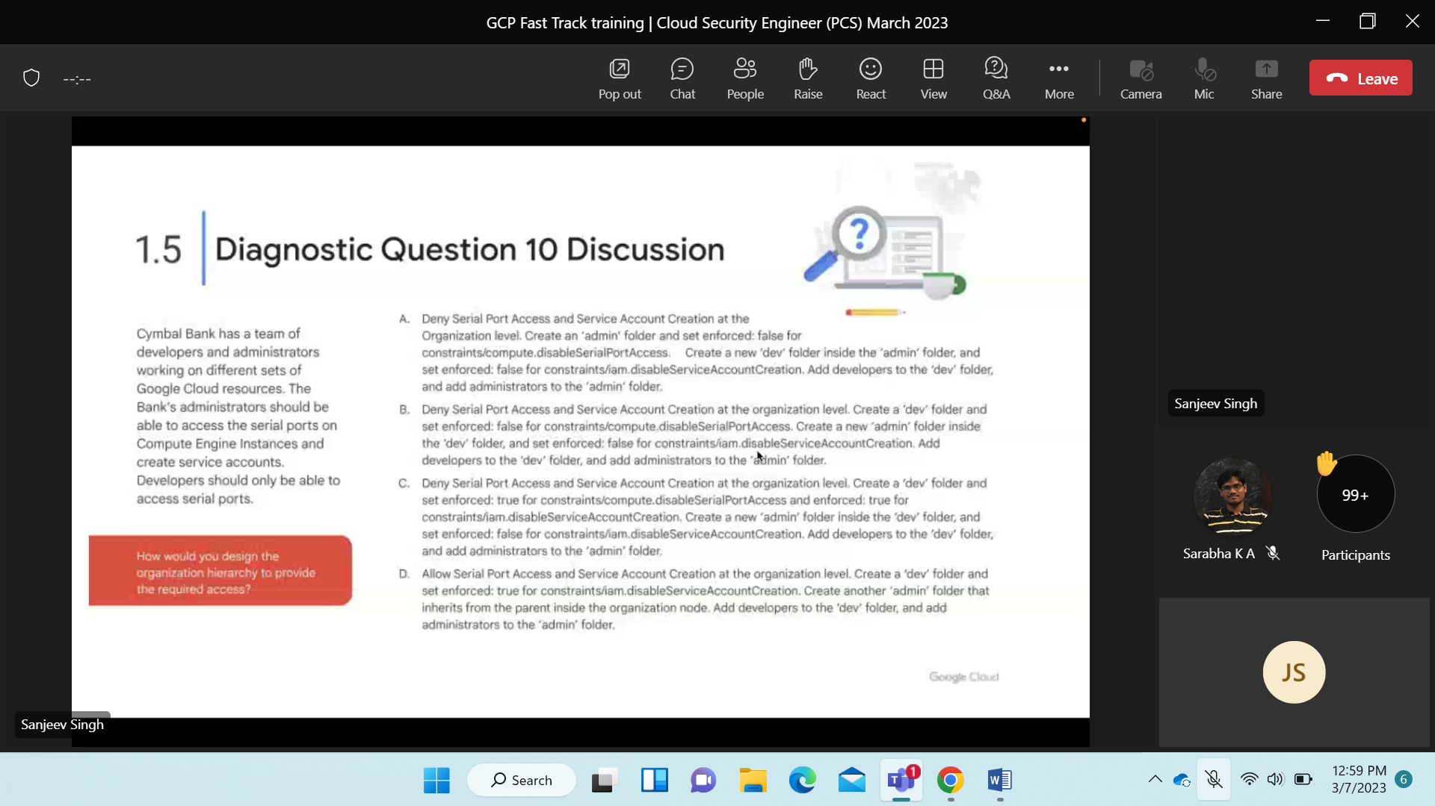

B right.. org constraint prevent all users accessing serial port.. restrict user from creat9ing acc. Constraint can be over-written..

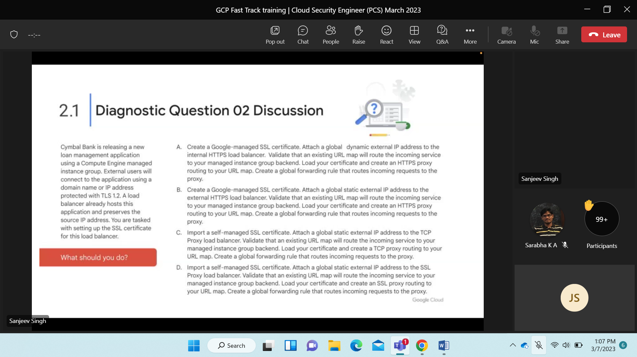

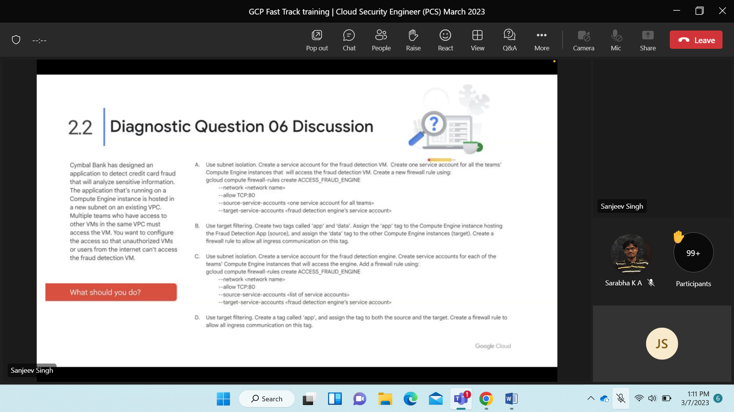

\ 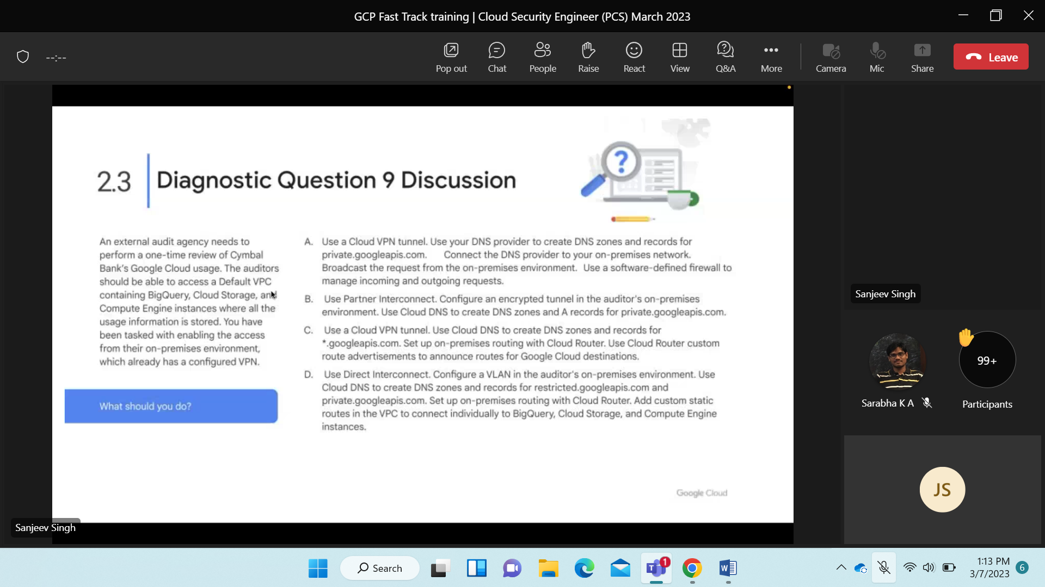

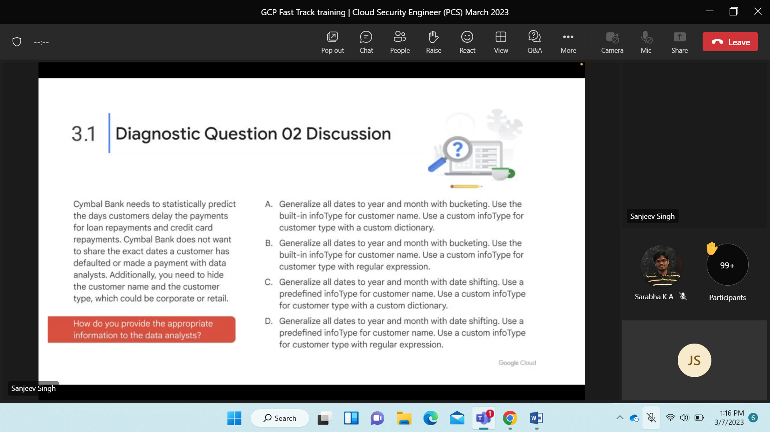

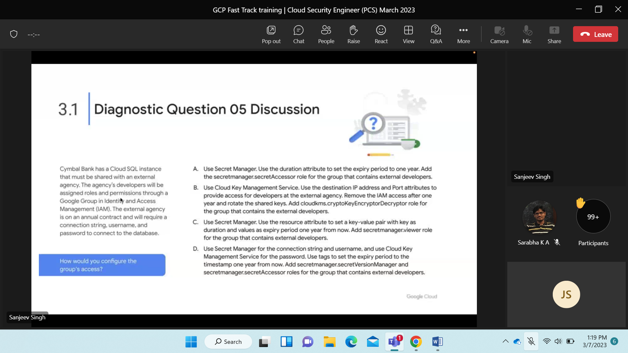

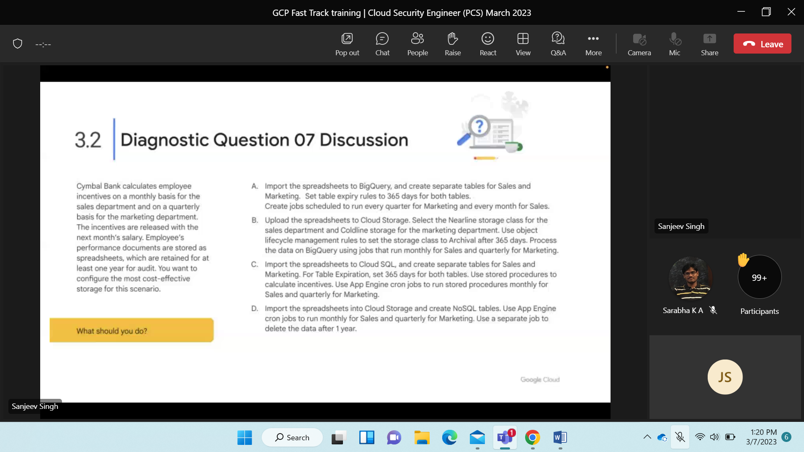

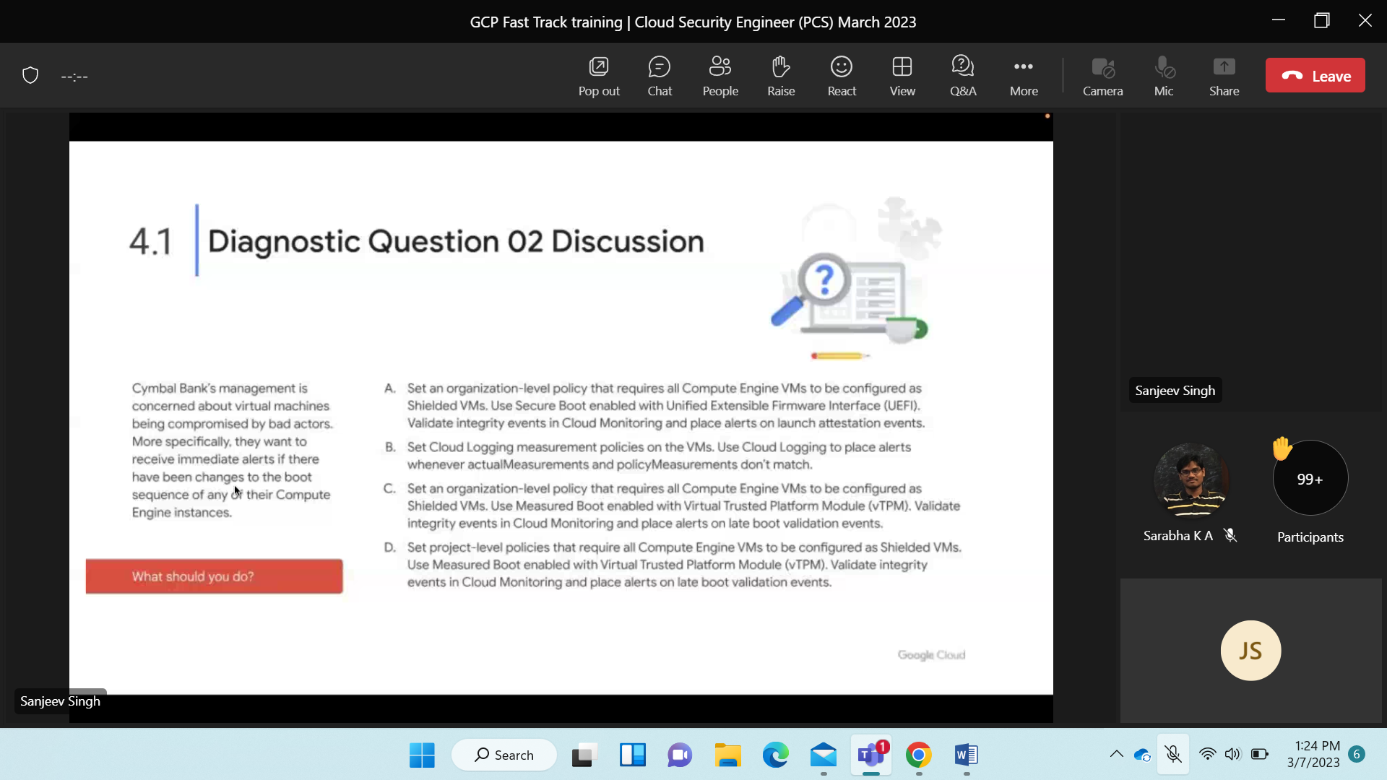

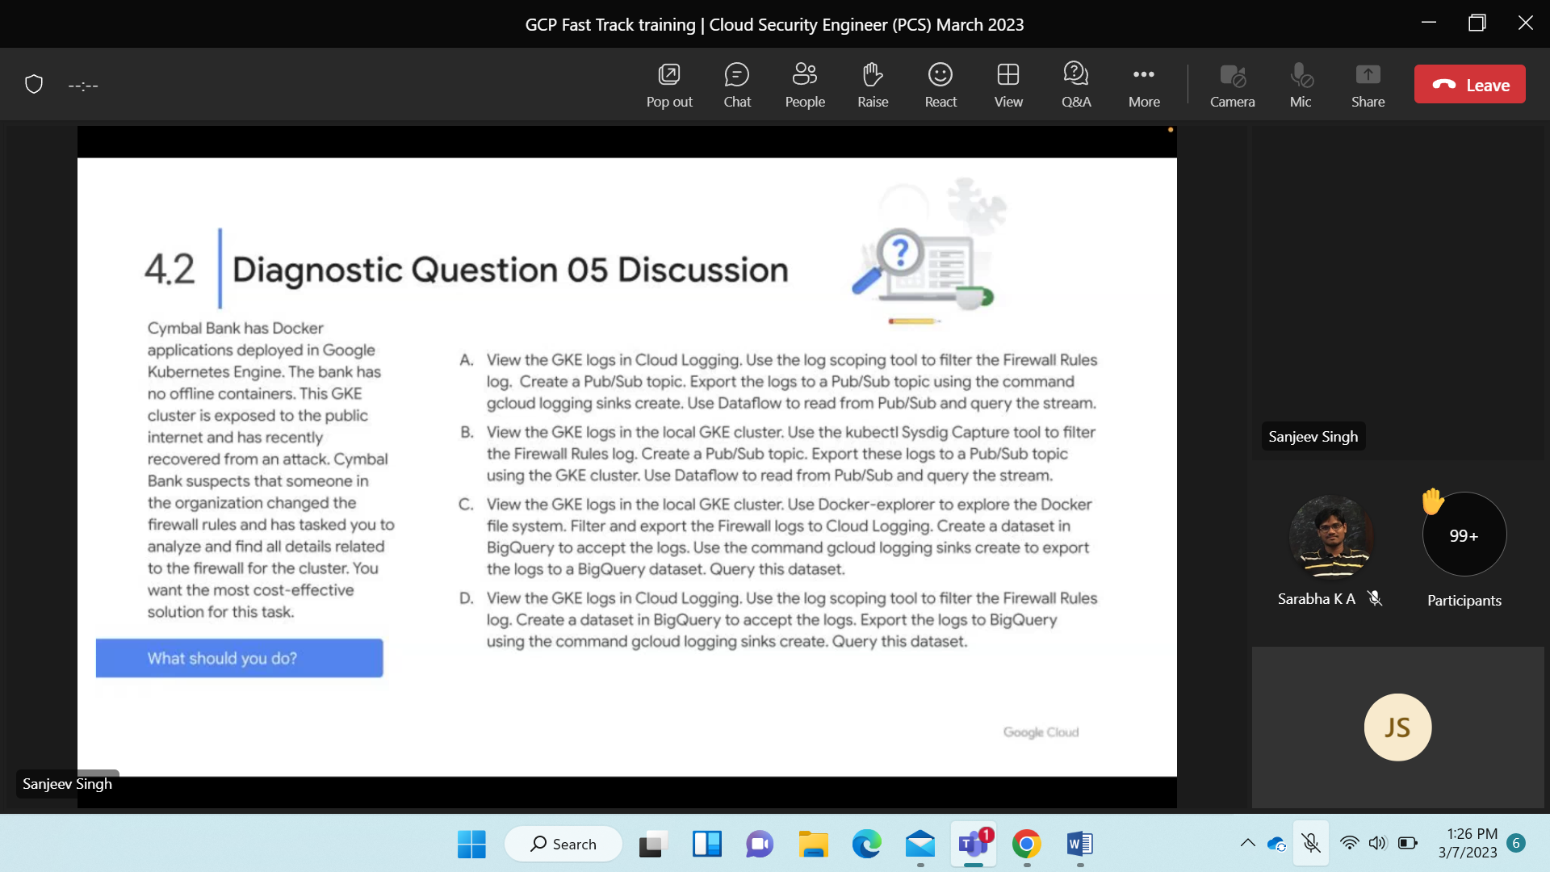

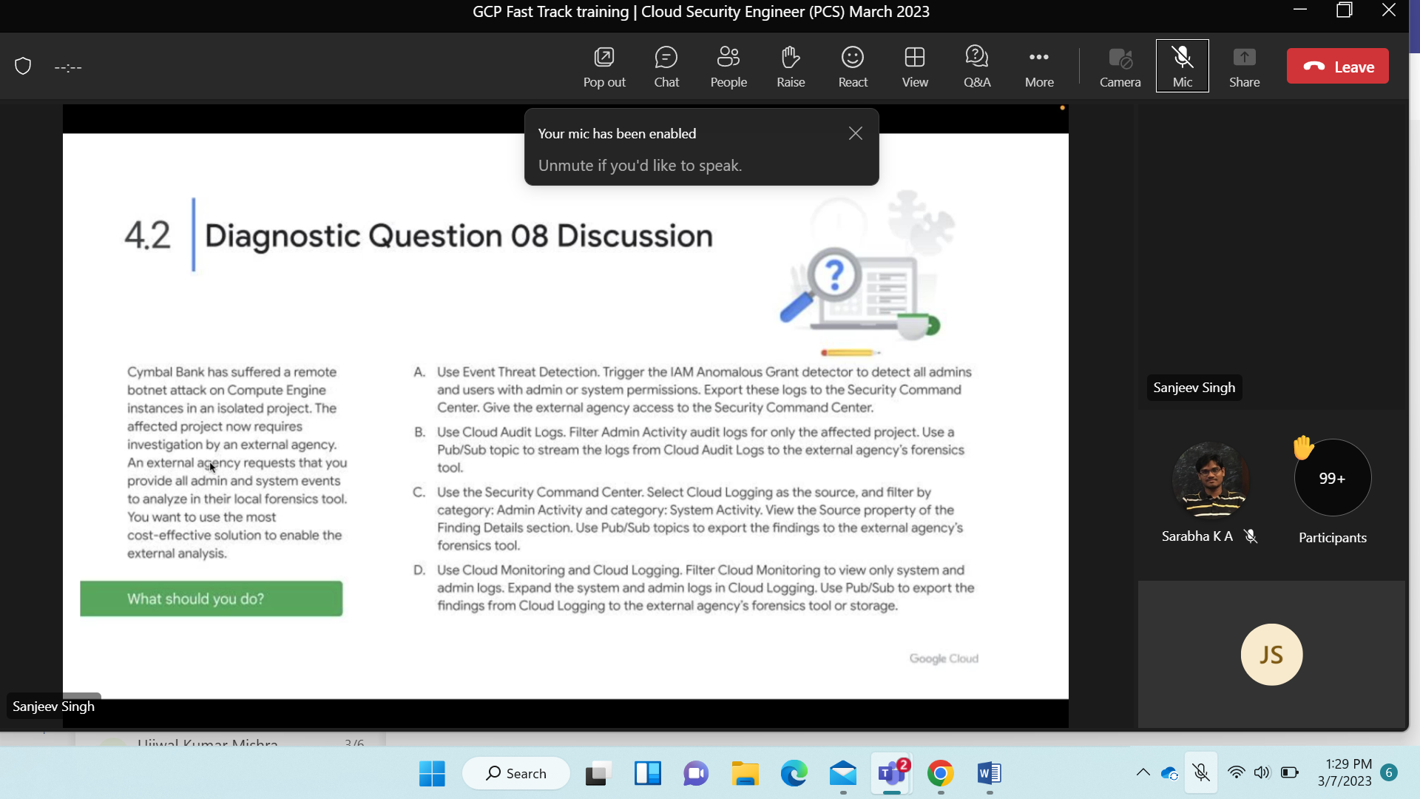

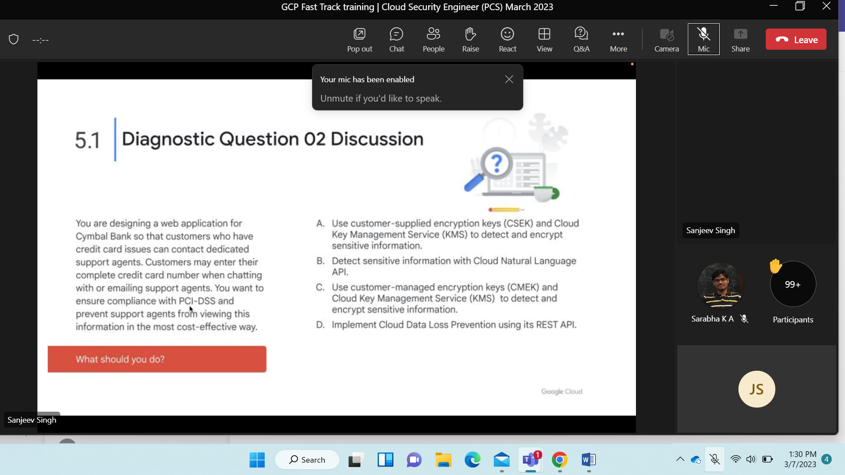

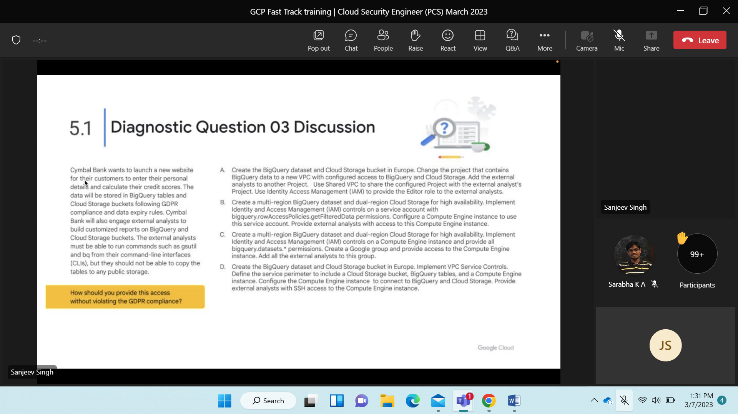

9 march

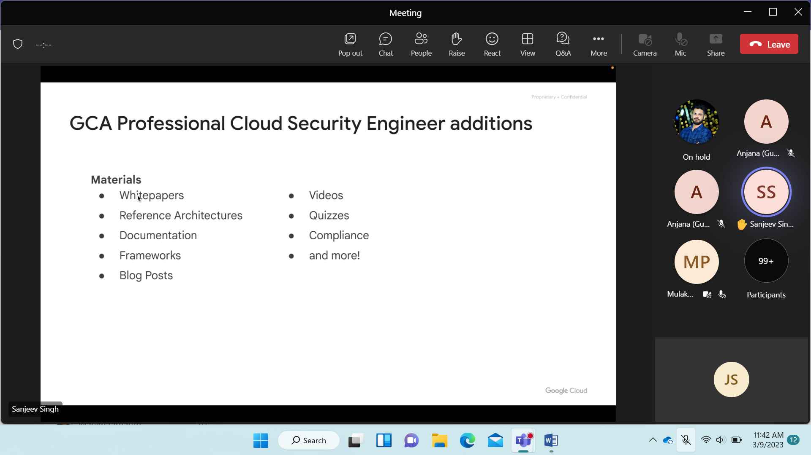

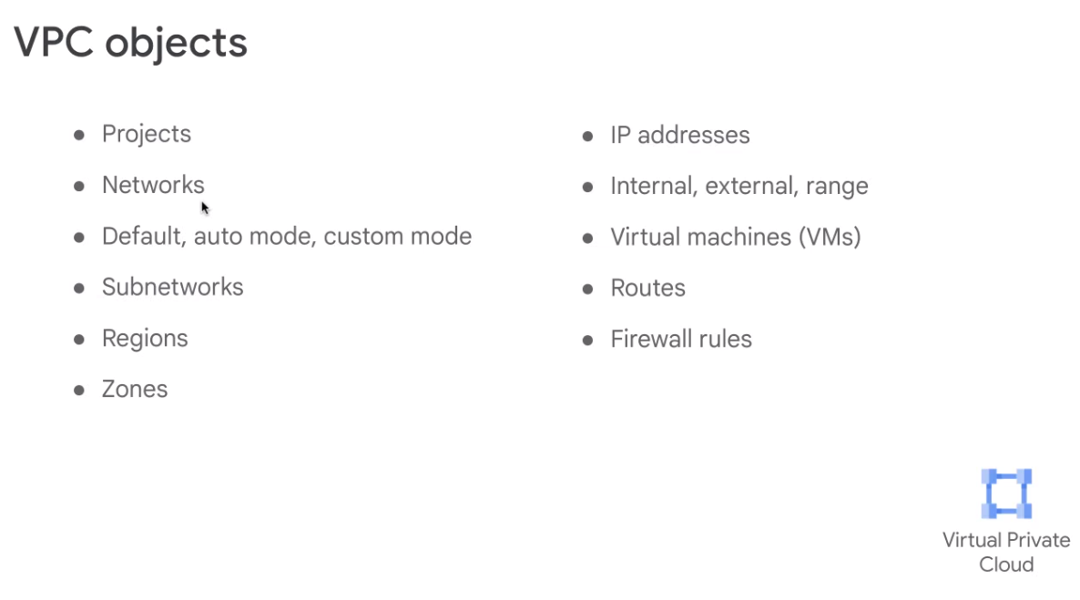

Manul n/w then auto mode, custom mode..

Subnet while creating it need to mentic vpc and region to be deployed..

Ip are ext and internal

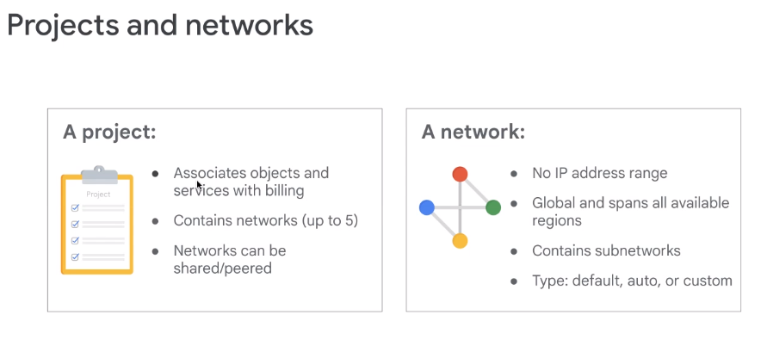

Eg- vpc from airbus and 1 from safras then also can be peer2peer

Global in nature.. subdivide into subnets..

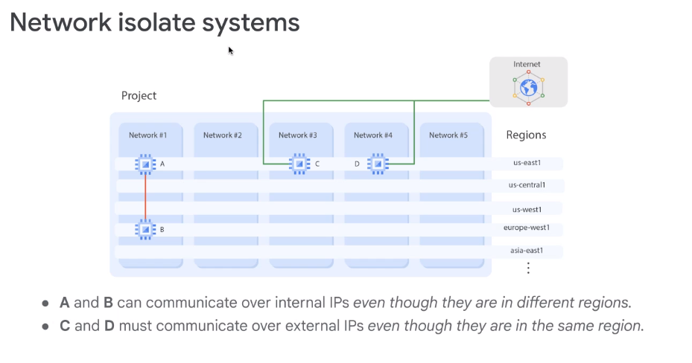

Same region A-B different region C-D

